1(a) .Iman-e-Mufassil and Iman-e-Mujmal.

1.IMAN-E-MUJMAL (The Summary Declaration of Faith).
Aamantu billaahi kamaa huwa bi-asmaa-ihi wa sifaatihi wa qabiltu jamee-a ahkaamihi.
I have faith in Allah as He is known by His Names and attributesand I accept all His commands.

2.IMAN-E-MUFASSIL (The Detailed Declaration of Faith).
Aamantu billaahi wa malaa-ikatihi wa kutubihi wa rusulihi wal yaumil aakhiri wal qadri khairihi wa sharrihi minallaahi ta'aala wal ba-si badal maut.
I have faith in Allah and His Angels, His Books and His Messengers, and the Day of Judgement and that all good and evil and fate is from Almighty Allah and it is sure that there will be resurrection after death .

1(a)-1.Kalimah:

1. Kalimah Tayyibah ( kalimat aṭ-ṭaiyibah).
لَا إِلٰهَ إِلَّا الله مُحَمَّدٌ رَسُولُ الله‎
'lā ilāha illā -llāh, muḥammadur rasūlu –llāh.
There is no god but Allah, (and) Muhammad is the messenger of Allah.

2. Kalimah Shahadah (kalimat ash-shahādah), (Word of Evidence).
أَشْهَدُ أنْ لا إلَٰهَ إِلَّا اللهُ وَحْدَهُ لَا شَرِيْكَ لَهُ وَأشْهَدُ أنَّ مُحَمَّدًا عَبْدُهُ وَرَسُولُهُ‎
Ašhadu an lā ilāha illā-llāh waḥdahu lā šarīka lahu, wa ašhadu anna muḥammadan ʿabduhu wa rasūluhu.
I bear witness that (there is) no god except Allah; One is He, no partner hath He, and I bear witness that Muhammad is His Servant and Messenger.

3. Kalimah Tamjeed (kalimat at-tamjīd ),(Word of Majesty).
سُبْحَان اللهِ وَالْحَمْدُلِلّهِ وَلا إِلهَ إِلّااللّهُ وَاللّهُ أكْبَرُ وَلا حَوْلَ وَلاَ قُوَّةَ إِلَّا بِاللّهِ الْعَلِيِّ الْعَظِيْم‎
Subḥāna-llāhi, wa-l-ḥamdu li-llāhi, wa lā ilāha illā-llāhu, Wa-llāhu akbar, Wa lā ḥawla wa lā quwwata illā bi-llāhi-l-ʿalīyyi-l-ʿaẓīm.
Exalted is Allah, and praise be to Allah, and there is no deity except Allah, and Allah is the Greatest. And there is no might nor power except in Allah, the Most High, the Most Great.

4. Kalimah Tawheed (kalimat at-tawḥīd), (Word of Oneness).
لَآ اِلٰهَ اِلَّا اللهُ وَحْدَهٗ لَا شَرِيْكَ لَهٗ لَهُ الْمُلْكُ وَ لَهُ الْحَمْدُ يُحْىٖ وَ يُمِيْتُ وَ هُوَحَیٌّ لَّا يَمُوْتُ اَبَدًا اَبَدًاؕ ذُو الْجَلَالِ وَالْاِكْرَامِؕ بِيَدِهِ الْخَيْرُؕ وَهُوَ عَلٰى كُلِّ شیْ ٍٔ قَدِیْرٌؕ‎
lā ilāha illā-llāhu waḥdahu lā sharīka lahu lahu l-mulku wa lahu l-ḥamdu yuḥyi wa yumītu wa huwa ḥayyu lā yamūtu abadan abadan dhu l-jalāli wa l-ʾikrām biyadihi-l khayr wa-huwa ʿala-kulli shayʾin qadīr.
"(There is) no god except Allah – One is He, no partners hath He. His is the Dominion, and His is the Praise. He gives life and sees to the natural cycle of life, life on Earth ends (death) for there is the eternal after life. He is eternal and ubiquitous. He of Majesty and Munificence. Within His Hand is (all) good. And He is, upon everything, Able (to exert His Will)."

5. Kalimah Istighfar (Word of Penitence).
اَسْتَغْفِرُ اللهِ رَبِّىْ مِنْ كُلِ ذَنْۢبٍ اَذْنَبْتُهٗ عَمَدًا اَوْ خَطَا ًٔ سِرًّا اَوْ عَلَانِيَةً وَّاَتُوْبُ اِلَيْهِ مِنَ الذَّنْۢبِ الَّذِیْٓ اَعْلَمُ وَ مِنَ الذَّنْۢبِ الَّذِىْ لَآ اَعْلَمُ اِنَّكَ اَنْتَ عَلَّامُ الْغُيُوْبِ وَ سَتَّارُ الْعُيُوْبِ و َغَفَّارُ الذُّنُوْبِ وَ لَا حَوْلَ وَلَا قُوَّةَ اِلَّا بِاللهِ الْعَلِىِ الْعَظِيْمِؕ‎
astaghfiru-llāhe rabbī min kulli dhanbin adnabtuhu ʿamadan ʾaw khaṭāʾan sirran ʾaw ʿalāniyyataw wa atūbu ʾilayhi minal dhanbi-lladhī aʿlamu wa minal dhanbi-lladhī lā aʿlamu innaka ʾanta ʿallāmul-ghuyūbi wa sattārul-ʿuyūbi wa ghaffāru dhunūbi wa lā ḥawla wa lā quwwata illā billāhil-ʿalīyyil-ʿaẓīm.
"I seek forgiveness from Allah, my Lord, from every sin I committed knowingly or unknowingly, secretly or openly, and I turn towards Him from the sin that I know and from the sin that I do not know. Certainly You, You (are) the knower of the hidden things and the Concealer (of) the mistakes and the Forgiver (of) the sins. And (there is) no power and no strength except from Allah, the Most High, the Most Great".

6. Kalima Radde Kufr ("Word of Rejection of Disbelief") .
اَللّٰهُمَّ اِنِّیْٓ اَعُوْذُ بِكَ مِنْ اَنْ اُشْرِكَ بِكَ شَيْئًا وَّاَنَآ اَعْلَمُ بِهٖ وَ اَسْتَغْفِرُكَ لِمَا لَآ اَعْلَمُ بِهٖ تُبْتُ عَنْهُ وَ تَبَرَّأْتُ مِنَ الْكُفْرِ وَ الشِّرْكِ وَ الْكِذْبِ وَ الْغِيْبَةِ وَ الْبِدْعَةِ وَ النَّمِيْمَةِ وَ الْفَوَاحِشِ وَ الْبُهْتَانِ وَ الْمَعَاصِىْ كُلِهَا وَ اَسْلَمْتُ وَ اَقُوْلُ لَآ اِلٰهَ اِلَّا اللهُ مُحَمَّدٌ رَّسُوْلُ اللهِؕ‎
Allāhumma innī aʿūḏu bika min an ušrika bika šayʾaw-wwa-anā aʿlamu bihi wa-staġfiruka limā lā aʿlamu bihi tubtu ʿanhu wa tabarra'tu mina-l-kufri wa-š-širki wa-l-kiḏhbi wa-l-ġībati wa-l-bidʿati wa-nnamīmati wa-l-fawāḥiši wa-l-buhtāni wa-l-maʿāṣī kullihā wa aslamtu wa aqūlu lā ilāha illā-llāhu Muḥammadu-r-rasūlu llāh.
" O Allah! I seek protection in You from that I should not join any partner with You and I have knowledge of it. I seek Your forgiveness from that which I do not know. I repent from it (ignorance) and I reject disbelief and joining partners with You and of falsehood and slandering and innovation in religion and tell-tales and evil deeds and the blame and the disobedience, all of them. I submit to Your will and I believe and I declare: There is none worthy of worship except Allah and Muhammad is His Messenger."

1-Purification and Cleanliness­(TAHAARAH):

Purification is a very important matter in Islam. One must purify their intention for Allah alone and purify their bodies and clothes before beginning the Prayer.
Hygiene and cleanliness sare very important aspects of a Muslim's life. One must ensure that their bodies,clothing and place of prayer is free from impurities such as urine, faeces and any other impure substances. After going to the toilet, it is recommended to wash the private parts with water if it is available and does not cause harm (due to injury fore xample).
It is obligatory to have a full shower known as Ghusl after intimate relations between the husband and wife,afte rejaculation (due to a wet dream, for example), and upon completion of a woman's menses orpost-natal bleeding.

1-1.Cleaning these ten is from ‘Fitrah’:

1. Circumcission
2. Cleaning nose with water
3. (Cleaning teeth) using Siwak (tooth stick)
4. Washing the joints
5. Washing with water after relieving oneself (from urinals and stools)
6. Letting the beard grow
7. Trimming the moustache
8. Clipping finger nails
9. Plucking the armpit hair
10. Shaving pubic hair
Note: This is the ancient sunnah (way) which was followed by all the Prophets and which was enjoined by all the laws they brought. It is a natural and innate way. Moustache, Fingernails, Armpit hair and Pubic hair should not be left for more than 40 days, without trimming, clipping or shaving them respectively.
1-2.Types of ritual impurities:

1-Minor Ritual Impurities.
(i).Something exiting private parts(ex: Urine, Feces, Wind, Prostatic fluid).
(ii).Unconsciousness(either due to fainting or deep sleep).
(iii).Touching private parts directly with hands(without barrier).
(iv).Sexual relations(foreplay and pre-cum).

2-Major Ritual Impurities.
(i).Sexual Intercourse(regardless of ejaculation).
(ii).Ejaculation of Sperm (Whether it occurs without desire or with desire, whether awake or asleep).
(iii).Menstrual Cycle or Post-natal bleeding.

1-3.How to remove impurity?
Intention to purify (whether major or minor ritual impurity), must be made.
- Major impurity nullifies Ghusl and is removed by performing Ghusl.
- Minor impurity nullifies Wudu and is removed by performing Wudu.

2.Types of ghusl by purpose
Ghusl becomes obligatory for seven causes, and the ghusl for each of these different causes has different names:
1.Ghusl Janabat is ghusl performed after sexual intercourse or ejaculation.
2.Ghusl Hayd is following menstruation.
3.Ghusl Istihadad is for irregular bleeding (in women).
4.Ghusl Nifas is for post-partum bleeding.
5.Ghusl Mayyit is ghusl performed on a dead Muslim.
6.Ghusl Mase Mayyit becomes obligatory if one directly touches a dead body.
7.Ghusl also becomes obligatory following a vow or oath to perform it.

2-1.Water requirements:
Similar to wudu, some water is permissible for use for ghusl whereas some water is not. Permissible water sources include:
Rainwater,Well water,Spring, sea, or river water,Water of melting snow or hail and Water of a big tank or pond.
Ghusl is not allowed with unclean or impure water or water extracted from fruit and trees.

2-2.The acts of ghusl:
The Quranic mandate for ghusl comes in surah an-Nisa:
يَا أَيُّهَا الَّذِينَ آمَنُوا لَا تَقْرَبُوا الصَّلَاةَ وَأَنْتُمْ سُكَارَىٰ حَتَّىٰ تَعْلَمُوا مَا تَقُولُونَ وَلَا جُنُبًا إِلَّا عَابِرِي سَبِيلٍ حَتَّىٰ تَغْتَسِلُوا ۚ وَإِنْ كُنْتُمْ مَرْضَىٰ أَوْ عَلَىٰ سَفَرٍ أَوْ جَاءَ أَحَدٌ مِنْكُمْ مِنَ الْغَائِطِ أَوْ لَامَسْتُمُ النِّسَاءَ فَلَمْ تَجِدُوا مَاءً فَتَيَمَّمُوا صَعِيدًا طَيِّبًا فَامْسَحُوا بِوُجُوهِكُمْ وَأَيْدِيكُمْ ۗ إِنَّ اللَّهَ كَانَ عَفُوًّا غَفُورًا
yā-ʾayyuhā lladhīna ʾāmanū lā taqrabū ṣ-ṣalāta wa-ʾantum sukārā ḥattā taʿlamū mā taqūlūna wa-lā junuban ʾillā ʿābirī sabīlin ḥattā taghtasilū wa-ʾin kuntum marḍā ʾaw ʿalā safarin ʾaw jāʾa ʾaḥadun minkum mina l-ghāʾiṭi ʾaw lāmastumu n-nisāʾa fa-lam tajidū māʾan fa-tayammamū ṣaʿīdan ṭayyiban fa-msaḥū bi-wujūhikum wa-ʾaydīkum ʾinna llāha kāna ʿafuwwan ghafūra

O you who believe! Do not approach the prayer while you are drunk, so that you know what you say; nor after sexual orgasm—unless you are travelling—until you have bathed. If you are sick, or traveling, or one of you comes from the toilet, or you have had intercourse with women, and cannot find water, find clean sand and wipe your faces and your hands with it. Allah is Pardoning and Forgiving.

2-3.Farā'id of Ghusl:
There are three fard (obligatory) acts. If one of these acts is omitted, it must be returned to and completed before the remaining acts.
1.Niyyah
2.Rinsing the inner mouth.
3.Sniffing water and blowing it out.

2-4.Sunnah of Ghusl:
Sunnah (optional - practised by Muhammad according to hadiths) acts.
1.Washing both the hands up to the wrists.
2.Wash the private parts and remove dirt or filth from the body.
3.Perform wudu.
4.Water should be poured over the head three times so that it flows all over the body.
5.Pour water on the right shoulder three times.
6.Pour water on the left shoulder three times.

2-5.Method of ghusl:
- Start by making niyyah (intention) to perform Ghusl, say Bismillah (in the name of Allah) and cleanse yourself of impurities.
- Wash the right hand up to and including the wrist (and between the fingers) three times, then similarly for the left hand.
- Wash the private parts and remove dirt or filth from the body.
- Perform Wudu as if for prayer. Ensure that the mouth and nostrils are thoroughly rinsed three times. If sitting on a stool or stone while bathing then the feet should also be washed when performing Wudu. But if sitting in a muddy place, feet should not be washed at this stage.
- Water should be poured over the head three times so that it flows all over the body, ensuring that the roots of hairs and parts not easily reached by water such as the backs of the knees are washed thoroughly.
- Pour water over both the shoulders three times each. Hands should be passed all over the body when water is poured so that no part of the body is left dry.
- Move to a clean spot and wash the feet if not washed during Wudu.
- As at the end of Wudu, it is recommended to recite the Shahada.
If, after Ghusl, one recalls that a certain portion of the body is left dry, it is not necessary to repeat the Ghusl, but merely wash the dry portion. It is not sufficient to pass a wet hand over the dry place. If one has forgotten to rinse the mouth or the nostrils, these too could be rinsed when recalled after Ghusl has been performed.
Ghusl should be made in a place of total privacy

3.WUDU (Ablution):

Before we perform Salah we must first prepare ourselves. This preparation includes making sure that we are clean from any physical impurities and performing Wudu. Wudu(ablution) is required for performing Salah. We cannot offer our Salah without first making Wudu. Here are the steps to take:

1. First, make the Niyyah
(intention) in your heart that this
act of Wudu is for the purpose of
preparing for Salah, and say:

Bismilla hir-rahma nir-Raheem.
I begin in the name of Allah, who is the Most Merciful, Most Gracious.
2. Wash both hands up to the
wrists, making sure that water has reached
between the fingers.Use your left
hand to wash your right hand (3 times).
After that, using your right hand,
wash your left hand. (3 times).

3. Take water with your right
hand, put it into your mouth and
Wash your whole mouth & upper
part of throat do this thoroughly
to get all the remaining food in
your mouth out. (3 times).

4.Take water with your right hand,
splash it into your nose and blow it out
three times. (Use the left hand if necessary
to help blow it out).

5. Wash your whole face three times
repeatedly. (The whole face includes:
the right ear to the left ear, and the
forehead to the bottom of the chin).
6. Wash the right arm thoroughly from
wrist to elbow three times, and make sure
that no part of the arm has been left
unwashed. Repeat with the left arm.
7. Move the palms of the wet hands
lightly over the head, starting from the top
of the forehead to the back of the head, and
passing both hands over the back of the head
to the neck, and thenbringing them back to
the forehead.

8. With the same water, rub the grooves and
holes of both ears with the wet index fingers,
while also passing the wet thumbs
behind the ears from the bottom upward.
9. Finally, wash both feet to the ankles
three times, starting with the right foot.
Make sure that water has reached between
the toes and covered the rest of the foot.
Or instead you can perform mas-h, if
you have the needed requirements
for doing it.
10. After Completion of Wudu.
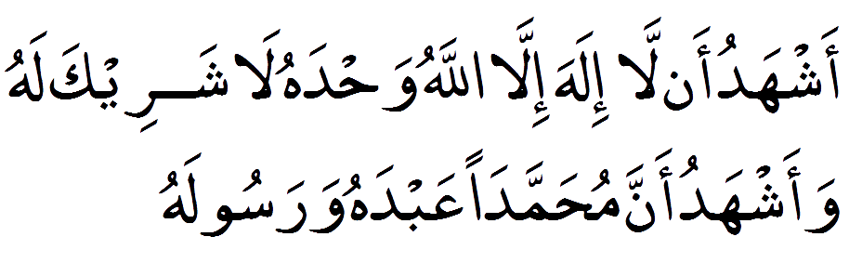
Ashhadu al la ilaha illal-lahu wahdahu la shareeka lah, wa-ashhadu anna Muhammadan aab-duhu warasooluh.
I testify that there is no one worthy of worship besides Allah. He is all by Himself and has no partner and I testify that Muhammad is Allah's Rasul (Messenger).

3-1.SPECIAL FACILITIES IN ABLUTION:

Rubbing the socks with wet hands instead of washing the feet; allowed, provided that the socks have been put on after performing an ablution, including washing the feet.
This is allowed for 24 hours from the time of ablution, and for 3 days if the person is on a journey. After this time the feet must be washed.
Similarly if there is a wound in any parts of the body which has to be washed in ablution, and if washing that particular part is likely to cause harm, it is permissible to wipe the dressing of the wound with a wet hand.

3-2.The Things that Break Wudu:

- Any discharge from the front or back passage (urine, stools, wind, etc.), except for wind emitted from a woman’s front passage – that does not break wudu’.
- Emission of urine or stools from anywhere other than the urethra or anus.
- Losing one’s mind, deep sleep, unconsciousness, intoxication, etc.
- Touching one’s penis.
- Eating camel meat.

4.Definition of At-Tayammum:
The Literal Meaning of At-Tayammum
Intending and striving towards something.
The Meaning of At-Tayamum in Islamic Law
Wiping the face and hands with clean soil, with the intention of purification.

4-1.Proofs for The Permissibilty of At-Tayammum:
1- Allah says : “ ... and when you don’t find water, then perform at-tayammum with clean earth and rub your faces and hands with it.” (Al-Ma’idah:6)
2- The Prophet ﷺ said: “I have been given five things which have not been given to anyone else before me: Allah made me victorious by causing my enemies to fear me up to a distance of one month’s journey, and the earth has been made for me (and my followers) a place for praying and a means to perform Tayammum (to purify oneself for prayer). Therefore, anyone (of my followers) can pray (anywhere) and at any time that the Salat (prayer) is due.”

4-2.When is At-Tayammum prescribed?

1. During the scarcity of water or its unavailability,But it’s said that a person is not considered as having a lack of water when he has not searched for it.

2. When one is incapable of using water, even when it is available,For example, a sick and/or an eldery person who cannot move and has no one to help him/her perform wudu.

3. When one fears he will be harmed by using water,Examples include:
a- A sick person whose use of water (for pruificaton) may aggravate his sickness;
b- A person experiencing extreme cold and does not have the means to warm water, coupled with a strong fear that he may fall sick from the use of cold water.
c-Someone far away from others or on a long journey with no water except a little for him to drink and he is not able to get other water.

4-3.Clean soil:
In Arabic terminology ‘soil’ means surface of the Earth. Most of the Arab lands are composed of sands and stones.The Prophet (sm) and His Sahabis used to make long tours on sandy desert land. Especially they were in great troubles for want of water during their journey to Tabook expedition about 750 k.m. from Madina at the month of Rajab’ 9th A.H./Oct’ 630 A.D. But it is not known that they carried soil from a long distance for Taiyammum. Therefore, the soil of earth-surface, sands and stones mixed with sands may be used for taiyammum. But it is not proper to make taiyammum with clean stones without soil or dust, or the wood, coal, iron, mosaic, plaster, tiles, lime etc.
Note: (1) After performing salat with Taiyammum, if water is available before the next time of salat, then the earlier salat should not have to be repeated.
(2) All things that can be performed with ablution can also be performed with Taiyammum. Similarly, everything that nullifies the ablution, nullifies Taiyammum also.

4-4.Description of At-Tayamum:
1- Strike the soil with both hands, once.
2- Then blow into the palms of the hands to reduce the particles therein.
3- Next wipe the face with the palms, once.
4- Then wipe the back of both hands, by wiping the back of the right hand with the palm of the left and vice versa.
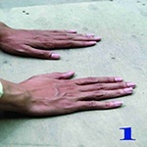(He strikes the dirt (earth) with both of his hands once).
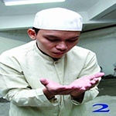 (He blows excess dirt from his hands).
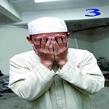 (He wipes his face with both hands).
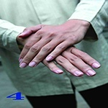 (He wipes his left hand with his right hand).
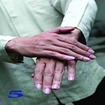 (He wipes his right hand with his left hand).

4-5.Compulsory Acts of At-Tayammum:
1- Intention.
2- Wiping the face.
3- Wiping the hands.
4- Sequentual order, starting with the face and then the hands.
5- Briskness, by wiping the hands immediately after the face.

4-6.Nullifiers of At-Tayammum:
1 -Availability of water;
2- Occurrence of any one of the nullifiers of wudu, like passing wind.
3- Occurrence of what necessitates bathing, like having a wet dream.
4- Absence or discontinuation of any reasons, e.g. sickness etc, that make at-tayammum permissible instead of wudu.

4-7.Issues for Discussion:
1- Making at-tayammum after relieving oneself - in the event that one is unable to use water and praying is better than praying with wudu’ while forcefully retaining urine and feces.
2- It is permissible to perform at-tayammum by using a wall, prayer mat etc., if soil or dust is present on them.
3- It is permissible for the person who performs at-tayammum to pray as many obligatory or optional prayers as he wishes, as long as the at-tayammum remains intact.
4- It is correct for the person who performed at-tayamum to lead the one who has performed wudu’ in Salat.
5- The person that performed at-tayammum and prayed, but then finds water before the time of that particular prayer finished, doesn’t have to repeat his or her prayer.
6- The person who performed at-tayammum but finds water before or while offering As Salah, must make wudu.
7- Nothing prevents a Muslim from observing Salah and he also must not delay it. If he is incapable of using water or he is not able to find it, he should perform at-tayammum, if he is not able to perform at-tayammum, he should pray without purification.
8- The one who lacks the two forms of purification (water and soil) should pray without purification when the time for As-Salah starts, and he doesn’t need to make up the prayer later on when he does find something to purify himself with.
9- It is permissible to delay at-tayammum until the last period of a particular Salah for someone who expects to find water. But when hope of finding water is lost, it is recommended to perform it early in its time; the best As-Salat is the one said at its prescribed time.
10- If a person fears that the period for a particular Salah might elapse and thus performed at-tayammum while water was available, the Salah is not valid. It is compulsory for him to perform wudu’ even if the time for the Salah may elapse.

5.Prayer (Sala,at):
Prayer, in the ritual sense, is an obligation of the faith, to be performed five times a day by adult Muslims. According to Islamic law, prayers have a variety of obligations and conditions of observance. However, beyond the level of practice, there are spiritual conditions and aspects of prayer which represent its essence.
Thus, prayer first and foremost, is the response to this Divine directive to worship the Creator. Prayer represents the individual’s affirmation of servant hood before the Lord of Creation and submission to His Omnipotent Will. It also represents a willing acknowledgment of our weakness and neediness by seeking Divine Grace, Mercy, Abundance and Forgiveness. Prayer, then, is a willful, directed action by the believer, seeking direct, unmediated communication with Allah, for Muslims believe that every human being is of interest to the Divine. It also represents a concrete manifestation of the Islamic conception of freewill, in that the decision to pray is one that must be made by each individual. In this way, prayer is a uniquely “human” form of worship, for all other creatures submit without question to Allah’s Will and are engaged in His praise, glorification and remembrance.
Prophet Muhammad ﷺ called prayer “the pillar of religion.” No fundamental element of Islam has been stressed as much as prayer in the Holy Qur’ān. Indeed, Allah mentions it in over 700 verses of the holy text. Thus, the ritual prayer is an obligation from Allah on every sane, adult Muslim.
The Prophet ﷺ said: The first thing about which a person will be questioned on the Day of Judgment is prayer. If it is found to be sound all his other actions will be sound as well. If his prayer is not sound all his remaining actions would be spoiled.
The Prophet ﷺ also said: Between a man and unbelief is giving up of ritual prayer.
The Prophet ﷺ also said: The one who missed Šalāt al-¿Ašr, just one of the ritual prayers, is as if he has lost all his family and property.
While the five prayers are an obligation, Muslims are also enjoined to perform other prayers in accordance with the practices of the Prophet Muhammad ﷺ. These include:
Witr (The final prayer to end the day), the two festival (Eid) prayers, the Eclipse Prayer and the Prayer for Rain. All the above are termed established traditions of the Prophet ﷺ.
Other than these are what are classified as voluntary worship.
In addition, there are a number of supererogatory prayers (sunan) which were part of the normative practice of the Prophet Muhammad ﷺ, and which remain part of the everyday worship of many traditionalist Muslims.
The five prayers are performed at specific times, which change daily in accordance with the continuous changes in the relationship between the Earth and the Sun. As a rule, prayers should be performed as early as possible after the start time. Delaying prayers should be avoided unless there is a necessity to do so.

5-1.The Adhan (Definition) :
‘Azan’ means the voice of declaration’. According to the terminology of Shari‘ah, this is the call of salat loudly in due time with Arabic sentences directed by the shari‘ah. Azan was introduced in the 1st year of hijrah.
5-2.Other information about Azan :
(1) The Muwazzin will chant Azan with loud voice facing the Qibla putting finger in two ears, so that the Azan becomes louder. He will turn the face only and not the body to right and left at the time of pronouncing Haiya ‘Alas Sala-h and Haiya ‘Alal Fala-h.

(2) The person who after Azan comes out of the mosque (without any important cause), he disobeys Abul Qasem [Muhammad ﷺ ].
(3) Who chants Azan will pronounce Iqamat. Other may pronounce it. But when an appointed Muwazzin is there, then with his permission other person may chant Azan and pronounce Iqamat. If the time is about to pass, then anybody may chant the Azan.
(4) The object of Azan will be to seek the satisfaction of Allah only. So it is not proper to ask any cost for it. But honorarium without seeking may be taken. Because the arrangement for honourable livelihood of a regular Imam and Muwazzin is an indispensable responsibility of the society and the state.

(5) Azan should be chanted with Ozu. But it is permissible to chant without Ozu. To answer to Azan or to utter any Tasbeeh, Tahleel and Doa is permissible even when someone is unclean.

(6) After Iqamat if cessation for a long time, another Iqamat will not be necessary.

(7) If someone comes after Azan and Jama-‘at, then the jama‘at and salat should be started with Iqamat only.

(8) For the Jama-‘at of due salat, Azan is not compulsory. Only Iqamat is sufficient.

5-3.The Adhan ( Calling for Group Prayer in a Mosque):
ألأذان
الله أكبرُ اللهُ أكبر ، الله أكبرُ اللهُ أكبر
أشهدُ ألآ إلهَ إلا الله ، أشهدُ ألا إلهَ إلا الله
أشهدُ أنَّ محمداً رسولُ الله ، أشهدُ أن محمداً رسولُ الله
حيِّ على الصلاة ، حيِّ على الصلاة
حيِّ على الفلاح ، حيِّ على الفلاح
اللهُ أكبرُ اللهُ أكبر
لا إلهَ إلا الله
Al- laa- hu Akbar, Al- laa- hu Akbar, Al- laa- hu Akbar, Al- laa- hu Akbar (intoned four times).
Ash- ha- du al- laailaahail- lal- laah, Ash- ha- du al- laailaahail- lal- laah (intoned twice).
Ash- ha- du an-na Muham-ma-dar Ra-soo-lul-laah, Ash- ha- du an-naMuham-ma-dar Ra-soo-lul-laah (intoned twice).
Hay- Ya alas- Salaah, Hay- Ya alas- Salaah ( intoned twice).
Hay- Ya alal- Falaah, Hay- Ya alal- Falaah ( intoned twice).
Al- laa- hu Akbar, Al- laa- hu Akbar ( intoned twice).
Laa- i-laa-ha il-lal- laah ( intoned once).

God is Great! God is Great! God is Great! God is Great!
I bear witness that there is no god except the One God.
I bear witness that there is no god except the One God.
I bear witness that Muhammad is the messenger of God.
I bear witness that Muhammad is the messenger of God.
Hurry to the prayer. Hurry to the prayer.
Hurry to salvation. Hurry to salvation.
God is Great! God is Great!
There is no god except the One God.
5-4.Fajr prayer:
(Note): For the pre-dawn (fajr) prayer, the following phrase is inserted prior to the final repetition of Allahu Akbar :

Assalatu khayrum minan naum الصلاة خير من النوم

Assalatu khayrum minan naum الصلاة خير من النوم
Prayer is better than sleep. Prayer is better than sleep.
5-5.Answer to Azan:
The Prophet ﷺ says,‘Whenever you hear the Azan, you say what the Muwazzin says’. In another place the Prophet ﷺ declares, ‘The person who repeats the words of Azan from the heart alongwith the Muwazzin and says, ‘La hawla wala Quwata illa billa-h’after ‘Haiya ‘Alas Sala-h’ and ‘Haiya ‘Alal Fala-h’ (There is no power, no strength except Alalh), that person will enter the Heaven. Therefore in Azan and Iqamat except ‘Haiya ‘Alas Sala-h’ and ‘Haiya ‘Alal Fala-h’ it is to be answered as same as the Muwazzin utters. The answer of Iqamat is to be as the answer of Azan. Because the Azan & Iqamat both are called Azan in hadeeth.
5-6.Doa of Azan:
After answering to Azan, the Darood is to be read first. Thereafter the Doa is to be read. The Prophet ﷺ said, ‘The person who after hearing the Azan would utter this Doa, my recommendation for him in the Day of Resurrection would be bounden’.
اَللَّهُمَّ رَبَّ هَذِهِ الدَّعْوَةِ التَّامَّةِ وَالصَّلاَةِ الْقَائِمَةِ، آتِ مُحَمَّدًانِ الْوَسِيْلَةَ وَالْفَضِيْلَةَ، وَابْعَثْهُ مَقَامًا مَّحْمُوْدًاِن الَّذِىْ وَعَدْتَهُ -
Alla-humma Rabba Ha-zihid Da‘watit ta-mmah, wassala-til qa-imah, A-te Muhammadanil waseelata wal Fazeelah, wab‘athhu Maqa-mam mahmoodanillzee wa‘adtah.
‘Oh Allah! You are the lord of this complete call (of Tawheed) and established salat. Grant Waseelah (The highest honoured place in the heaven) to Muhammad and give him honour and send him to ‘Maqam-i-Mahmood’ the most praise-worthy place (for shafa‘at i.e. recommendation) in the Heaven, which you have promised’.
5-7.Iqamat:
Iqamat means to make one stand. Iqamat is to utter for making the present musallis alert for standing to salat. Either in congregation or alone, it is sunnat to chant Azan and Iqamat before all Farz salats.
(Note): Another line is always added after Hay- Ya alal- Falaah, in Iqama (Announcing the start of prayer) before few seconds of the every prayer:

Qad Qamates salah, Qad qamates salah ( intoned twice).
The prayer has begun, The prayer has begun.

ألإقامة
الله أكبرُ اللهُ أكبر ، الله أكبرُ اللهُ أكبر
أشهدُ ألآ إلهَ إلا الله ، أشهدُ ألا إلهَ إلا الله
أشهدُ أنَّ محمداً رسولُ الله ، أشهدُ أن محمداً رسولُ الله
حيِّ على الصلاة ، حيِّ على الصلاة
حيِّ على الفلاح ، حيِّ على الفلاح
قد قامت الصلاةُ ، قد قامت الصىلاة
اللهُ أكبرُ اللهُ أكبر
لا إلهَ إلا الله
5-8.When to Recite Aloud or Silently:

During obligatory Fajr prayers, you recite the Qur'an aloud in both Rak'ahs. You also recite the first two Rak'ahs of the obligatory prayers of Maghrib and 'Isha aloud as well.

However, the third and fourth Rak'ahs are always recited silently during obligatory prayers. Also, in the Dhuhr and Asr prayers, the recitation is always silent for all four Rak'ahs.

Furthermore, the one who leads Jumu'ah prayers (Friday prayer in place of Dhuhr) will recite the Qur'an aloud.

5-9.PRAYER:

Entering the Mosque say.
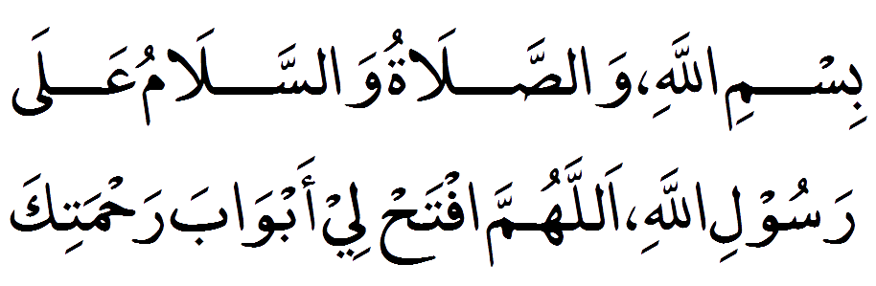
Bismil-lah, wassalatu wassalamu ala rasoolil-lah, allahummaf tah-lee aab-wa ba rahmatik.
In the Name of Allah, and peace and blessings be upon the Messenger of Allah, O Allah, open the doors of mercy.

Intention and Takbeer.

As a Muslim stands for prayer, he/she has the intention to perform it, that's why it is unnecessary to say that he/she intends to pray. Then, they lift their hands up to the levels of ears making the Takbeer, which is the start of prayers.

(Takbira tul Ihram).
اللهُ أكبر Allahu Akbar (Allah is the Greatest)
(Qiyaam).
Now place your right hand on top of your left hand on the chest and look downward to the place where your forehead will touch the ground in the Sujood (prostration) and recite silently (Sanaa ):
سبحانك اللهم و بحمدك، وتبارك اسمك، و تعالى جدك، ولا إله غيرك

"Subhanaka allahumma wa bi hamdika wa tabara kasmuka wa ta'ala jadduka wa la ilaha ghairuka."

“O Allah, how perfect You are and praise be to You. Blessed is Your name, and exalted is Your majesty. There is no god but You.” [Only recite this supplication, Subhanaka, at the beginning of the first Rak'ah]

Then recite silently(Ta'awwudh):
أعوذ بالله من الشيطان الرجيم

"A'udhu billahi minash shaitanir rajim."
“I seek shelter in Allah from the rejected Satan.”

Then recite (Tasmiyah):
بسم الله الرحمن الرحيم
"Bismillahir rahmanir rahim."
“In the name of Allah, the most Gracious, the most Merciful.”

After this, recite Suratul Fatihah of the Noble Qur'an:
بِسْمِ اللَّـهِ الرَّحْمَـٰنِ الرَّحِيمِ ﴿١﴾
لْحَمْدُ لِلَّـهِ رَبِّ الْعَالَمِينَ ﴿٢﴾
الرَّحْمَـٰنِ الرَّحِيمِ ﴿٣﴾
مَالِكِ يَوْمِ الدِّينِ ﴿٤﴾
إِيَّاكَ نَعْبُدُ وَإِيَّاكَ نَسْتَعِينُ ﴿٥﴾
اهْدِنَا الصِّرَاطَ الْمُسْتَقِيمَ ﴿٦﴾
صِرَاطَ الَّذِينَ أَنْعَمْتَ عَلَيْهِمْ غَيْرِ الْمَغْضُوبِ عَلَيْهِمْ وَلَا الضَّالِّينَ ﴿٧﴾
Bismilla-hir-Rahmaanir-Raheem.
Alhamdu lillahi Rabbil-’alameen. Ar-Rahmanir-Raheem. Maliki yawmid-deen. Iyyaka na’budu wa iyyaka nasta’een. Ihdinas- siratal-mustaqeem. Siratal-ladheena an’amta ‘alayhim, ghayril- maghdoobi ‘alayhim walad-dalleen.” Ameen

1 .In the name of Allah, the Gracious, the Merciful.
2 .Praise be to Allah, Lord of the Worlds.
3 .The Most Gracious, the Most Merciful.
4 . Master of the Day of Judgment.
5 . It is You we worship, and upon You we call for help.
6 . Guide us to the straight path.
7 . The path of those You have blessed, not of those against whom there is anger, nor of those who are misguided.

(Note): Saying of the Prophet ﷺ:“Prayer without reciting the Al-Fatihah is invalid”. Upon completion of the "Al-Fatihah" the person says "Ameen" loudly. You must recite Surat Al-Fatihah in each unit (Rak’ah) of the prayer, if you pray alone. However, if praying behind an Imam and he recites loudly, then it is not necessary for you to recite it.

Now recite any other Surah or verses from the Noble Qur'an.

بِسْمِ اللَّهِ الرَّحْمَٰنِ الرَّحِيمِ
قُلْ هُوَ اللَّهُ أَحَدٌ {1} اللَّهُ الصَّمَدُ {2} لَمْ يَلِدْ وَلَمْ يُولَدْ {3} وَلَمْ يَكُنْ لَهُ كُفُوًا أَحَدٌ {4}
Bismilla-hir-Rahmaanir Raheem
Qul huwal-lahu ahad. Allahus-Samad. Lam yalid wa lam yuulad. Wa lam yakul-lahu kufuwan ahad.

“In the name of Allah, the most Gracious, the most Merciful.
Say, He is Allah, the One. Allah is Eternal and Absolute. He begets not, nor was He begotten. And there is none co-equal unto Him.”

(Ruku):
Then, the person proceeds to "Rukuu" (bowing) position saying "ALLAHU AKBAR".
اللهُ أكبر Allahu Akbar (Allah is the Greatest)

While in this position the person is required to exercise serenity and tranquility positioning the head and back on the same level, putting both hands on the knees with the fingers spread and saying the following words for at least three times: "SUBHANA RABBIYAL A'ZIM”.

سُبْحَانَ رَبيَّ العَظِيم Subhaana Rabbiyal Azeem(3,5,7 or 9 Times)
(How Perfect is my Lord, the Supreme)
(Qauma position):
Then, the person raises from the "Rukuu" position saying: "SAMI AALLAHU LIMAN
HAMIDAH".

سَمِعَ اللهُ لِمَن حَمِدَه Sami-Allahu liman hamidah (Allah hears those who praise Him)
However, if a person following an Imam in a congregational prayer is not able to complete the above supplication it suffices to say: "RABANA LAKA ALHAMD".
The person then,immediately recites the following supplication while still standing: "RABBANA LAKA AL HAMDU.
الحمد لك ربنا Rabbana Lakal-Hamd (Our Lord, praise be to You)
Sujoud (Prostration):
A person makes sujoud, by making Takbeer first saying Allahu Akbar,.

اللهُ أكبر Allahu Akbar (Allah is the Greatest)

And touching the ground with the knees first before the hands While in prostration, the person should place seven parts of the body on the ground. These parts are the forhead, together with the nose, both palms of the hands (fingers should be stretched, closed together and pointed towards the direction of the Qiblah), both knees, the bottom parts of the toes of both feet (toes pointed to the direction of the Qiblah).

During the prostration, the person says for three times or more the following words:"SUBHANA RABBIYAL AALA".
سُبْحَانَ ربيِّ الأعْلَىSub'hana rabiyal ‘ala (3,5,7 or 9 Times) (How Perfect is my Lord, the Highest)
اللهُ أكبر Allahu Akbar (Allah is the Greatest)
Then, the person lifts his head while sitting (in Jalsah position) on the floor saying Allahu Akbar .Sit upright with your knees bent and palms placed on them.

Then goes down to perform another Sujoud after few seconds by making Takbeer first saying Allahu Akbar, and Recite "Subhana Rabbiyal A'la" for three times or more.
سُبْحَانَ ربيِّ الأعْلَىSub'hana rabiyal ‘ala (3,5,7 or 9 Times) (How Perfect is my Lord, the Highest)
Then the person thereafter, says ALLAHU AKBAR and stands up for the second Rakaat.
اللهُ أكبر Allahu Akbar (Allah is the Greatest)
This completes the first Rak'ah or unit of Salah.
(Second Rakaat):
Now stand up for the second Rak'ah and perform it in the same way, except that you do not recite Subhanaka at the beginning, and after the second Sujood (prostration) person sit for Tashahud (in Jalsah position).

Tashahud
Then the person takes a sitting for the "Tashahud" and while in this position, the fingers of the right hand are to be placed close-fisted except the index finger which the person uses to point out as an indication for monotheistic belief although, the person may as well keep both the little and the ring fingers closed, while rounding the thumb and middle finger in a ring-shaped form and uses the index finger to point out as a sign for monotheistic belief. The left hand is placed on the left knee with the fingers kept open. After sitting as discussed above, the person recites the Tashahud silently as follows:
التَّشَهُد The Proclamation and Bear Witnessing
التحيات لله والصلوات والطيبات، السلام عليك أيها النبي ورحمة لله
وبركاته، السلام علينا و على عباد الله الصالحين، أشهد أن لا إله إلا الله، وأشهد أن محمدا عبده و رسوله.

“At-tahiyatu lillahi was-salawatu wat-tayyibatu as-salamu ‘alayka, ayyuhan-nabiyyu wa rahmatullahi wa barakatuhu, as-salamu ‘alayna wa ‘ala ‘ibadul-lahis-saliheen. Ashhadu alla ilaha illallahu wa ashhadu anna Muhammadan abduhu wa Rasuluhu.”

This means: “Greetings, prayers and goodness belong to Allah. Peace be on you,O Prophet and the mercy of Allah and His blessings. Peace be on us and on the righteous servants of Allah. I bear witness that there is no god but Allah, and bear witness that Muhammad is His servant and Messenger.”

(Note):In a three-Rak'ah Salah (as in Maghrib) or a four-Rak'ah Salah (Dhuhr, Asr, and Isha) you stand up for the remaining Rak'ah(s) after you have done Tashahhud. For a two-Rak'ah Salah you remain seated after Tashahhud and then recite silently Assalatul-Ibrahimiyah:

Darood Sharif
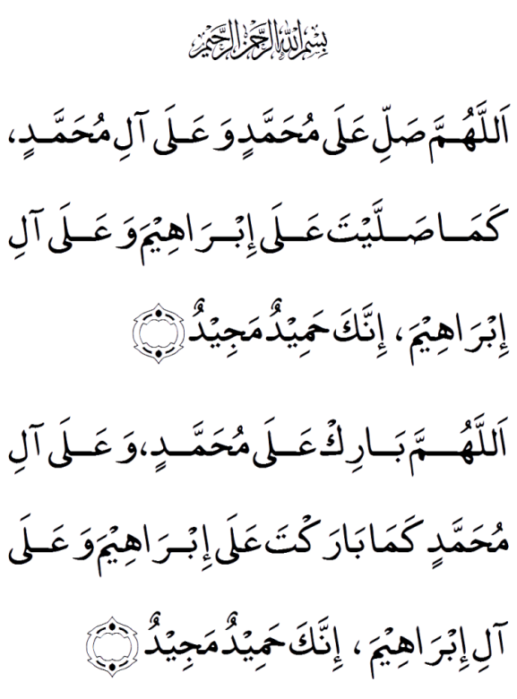
Bismillaahir Rahmaanir Raheem.
Allah humma salli ‘ala muhammadin wa’ala ali muhammadin,kama sal’layta ‘ala ibraheema wa’ala ali ibraheema innaka hameedum majeed.
Allah humma baraka ‘ala muhammadin wa’ala ali muhammadin, kama barak ta ‘ala ibraheema wa ‘ala ali ibraheema innaka hameedum majeed.

O Allah, let Your Blessings come upon Muhammad and the family of Muhammad, as you have blessed Ibrahim and his family. Truly, You are Praiseworthy and Glorious.
Allah, bless Muhammad and the family of Muhammad, as you have blessed Ibrahim and his family. Truly, You are Praiseworthy and Glorious.

Du’a
رَبِّ ٱجعَلنِى مُقِيمَ ٱلصَّلَوةِ وَمِن ذُرِّيَّتِى رَبَّنَا وَتَقَبَّل دُعَآءِ
Rabbi-Ajal’ni muqeema salaati, wa min Dhurriyyati, rabbana wataqabbal duaa.
O my Lord! make me one who establishes regular Prayer, and also (raise such) among my offspring O our Lord! and accept Thou my Prayer.
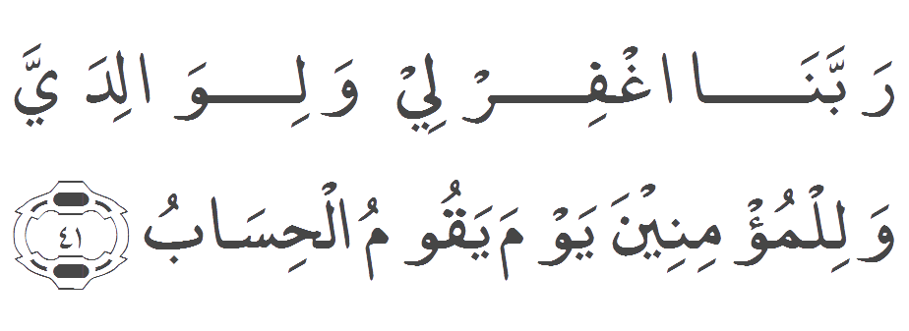
Rabbana ghfir li wa li wallidayya wa lil Mu'mineena yawma yaqumul hisaab.
O our Lord! Cover (us) with Thy Forgiveness – me, my parents, and (all) Believers, on the Day that the Reckoning will be established!

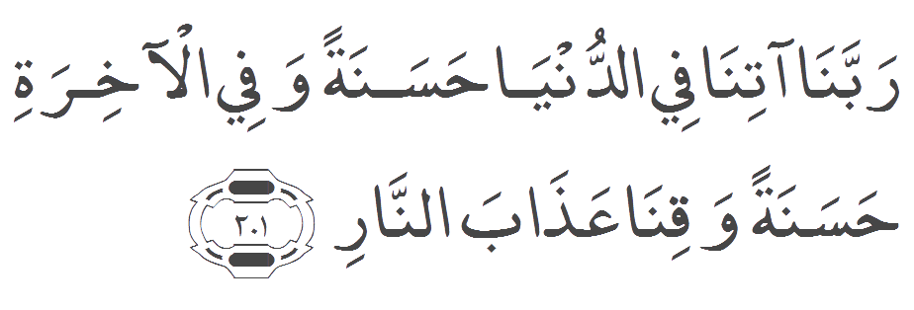
Rabbana atina fid-dunya hasanatan wa fil 'akhirati hasanatan waqina 'adhaban-nar.
Our Lord! Grant us good in this world and good in the hereafter, and save us from the chastisement of the fire.

Having completed the At-Tashahud,Darood and Dua the person terminates the prayer by saying two times: "AS-SALAMU ALEYKUM WA RAHMATU-LAAH",

اَلسَلامُ عَلَيْكُم وَرَحْمَةُ اَللهِ وَبَرَكاتُهُ‎, اَلسَلامُ عَلَيْكُم وَرَحْمَةُ اَللهِ وَبَرَكاتُهُ‎
as-salāmu ʿalaykum wa-raḥmatu llāhi wa-barakātuhu,
as-salāmu ʿalaykum wa-raḥmatu llāhi wa-barakātuhu.

(peace and the mercy of Allah be on you), (peace and the mercy of Allah be on you).

Leaving the Mosque say.
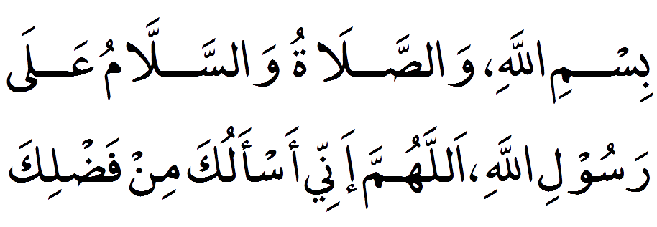
Bismil-lah – wassalatu wassalamu ala rasoolil-lah, allahumma innee as-aluka min fadlik.

In the Name of Allah, and peace and blessings be upon the Messenger of Allah. O Allah, I ask for Your favor, O Allah, protect me from Satan the outcas.

5-10.Sala,at Step by Step:

Two Raka,at Frjr.
● Step 1 (Takbeer Olaa)
● Step 2a (Al-Qayaam)
● Step 2b (Al-Qayaam)
● Step 3 (Surah Fatiha)
● Step 4 (Surah Kausar)
● Step 5 (Takbeer)
● Step 6 (Ruku)
● Step 7 (Qauma)
● Step 8 (Takbeer)
● Step 9 (Sajdah)
● Step 10 (Takbeer)
● Step 11 (Takbeer)
● Step 12 (Sajdah)
● Step 13 (Takbeer)
● Repeat Steps 3 to 13
● Step 14 (Jalsa)
● Step 15 (Al-Tashahud)
● Step 16 (Durood Shareef)
● Step 17 (Dua)
● Step 18 (Salam)

3 RAKA,AT MAGHRIB
● Step 1 (Takbeer Olaa)
● Step 2a (Al-Qayaam)
● Step 2b (Al-Qayaam)
● Step 3 (Surah Fatiha)
● Step 4 (Surah Kausar)
● Step 5 (Takbeer)
● Step 6 (Ruku)
● Step 7 (Qauma)
● Step 8 (Takbeer)
● Step 9 (Sajdah)
● Step 10 (Takbeer)
● Step 11 (Takbeer)
● Step 12 (Sajdah)
● Step 13 (Takbeer)
● Repeat Steps 3 to 12

● Step 14 (Takbeer)
● Step 15 (Jalsa)
● Step 16 (Takbeer)
● Repeat Steps 3 to 12
● Repeat Steps 14 and 15

● Step 16 (Durood Shareef)
● Step 17 (Dua)
● Step 18 (Salam)

5-11.Salatul Witr:

The "Witr" (Odd Number Prayer) is a voluntary prayer traditionally practiced by the Prophet ﷺ regularly whether he was present at his home place as a resident, or was on a journey. Such was the importance attached to this prayer by the Prophet ﷺ, that some Muslim jurists and scholars are of the opinion that it is a necessary prayer.

The time for the Witr Prayer begins from the end of Isha (Evening) prayer and continues until the Fajr (Dawn) prayer and is performed as the last prayer of the night.

It is known as Witr (Odd Number) prayer because of its nature, in that, it is completed in units (rakaats) of odd numbers, thus, 1, 3, 5, 7, 9, and 11.

However, Muslims largely performed this prayer in three units (rakaats) which may be performed in either of the following methods:

- First two Raka'ats are like any other prayer. In the first rakah You recite tauz, tasmeeh then say sana'a and recite surah fatehah and then you recite some ayats from any chapter of Quran, perform ruku and sijda and then stand up for the second rakah, repeat the above process, except saying tauz, tasmeeh and sana'a, recite surah e fatehah and some ayats from any chapter of Quran and perform ruku and sijda.
- In second rakah after getting up from the second sijda you sit down and recite tashahud.

- Then you get up for the third rakah. Recite surah e fatehah and some ayats from any chapter of Quran. Let's say you recited surah e fateha and surat al - Iklaas then after surat al - Ikhlaas you should say takbeer (Allah o Akbar) and raise your hands up to the air and then fold them again and then recite Dua e Qunoot.

- After reciting Dua e Qunoot you go on performing ruku and sujood after which you sit down and say tashahud and tasleem and then conclude the prayer.

5-12.Sala,at Witr Step by Step:

3 Raka,at Witr.
● Step 1 (Takbeer Olaa)
● Step 2a (Al-Qayaam)
● Step 2b (Al-Qayaam)
● Step 3 (Surah Fatiha)
● Step 4 (Surah Kausar)
● Step 5 (Takbeer)
● Step 6 (Ruku)
● Step 7 (Qauma)
● Step 8 (Takbeer)
● Step 9 (Sajdah)
● Step 10 (Takbeer)
● Step 11 (Takbeer)
● Step 12 (Sajdah)
● Step 13 (Takbeer)
● Repeat Steps 3 to 12
● Step 14 (Takbeer)
● Step 15 (Jalsa)
● Step 16 (Takbeer)
● Repeat Step 3 and 4
● Repeat Step 1
● Step 17 (Dua e Qunoot)
● Repeat Steps 5 to 12
● Repeat Steps 14 and 15
● Step 18 (Durood Shareef)
● Step 19 (Dua)
● Step 20 (Salam)

5-13.What to do when praying in a congregation:

Performance of the prayer together with the other Muslims in congregation at Mosques is a duty required from every male Muslim of sound mind. The Prophet ﷺ Said:“Performing prayer in congregation is 27-times better than prayer performed on individual basis”.

Congregational prayer is incumbent upon every male Muslim unless a person is excused from doing so as a result of one or more of the following reasons:
1.Sickness.
2.Fear that going to the Mosque will bring about undue hardships, or peril from an enemy.
3.Heavy rain.

It is permitted for women to attend the congregational prayers at the mosques and their husbands may not prevent them from doing so unless it is feared that harm will come to them. However, it is preferable for women to perform prayers at their homes.

If, however, women decide to go out for prayer at the mosques, they should neither dress nor perfume themselves in a manner that may attract the attention of men.At the mosques, it is an established tradition that women perform their prayers preferably in their own partition behind the rows of men.

If you are praying with another person, you should stand next to that person on the right, but never ahead. If there are two or more people praying with the Imam, then they should line up behind him.

We should also line up behind the Imam in straight rows. Men should pray in front, with men only. Women should pray behind the men, with women only. If a man and a woman are praying together, the woman should stand directly behind the man, not to his right.

We should follow the Imam's actions and statements, and make sure never to get ahead of him.

All gaps should be filled by connecting shoulders to shoulders and feet to feet. Your legs should be spread the same width as your shoulders.

We should not cross in front of a person who is praying.

Pray closer to a wall if possible. If not, place a barrier (chair, etc.) in front of you.

If you have come late to prayer and you catch the Imam before he has risen from the position of Rukoo', then you may count that Rak’ah as if you have prayed it.

However, if you have caught the Imam after he has risen from Rukoo', then you must follow the Imam until Tasleem. Do not make Tasleem; instead, get up and make-up the Rak'ah(s) that you missed.

5-14.Sujood As-Sahu (The prostration of forgetfulness):

As human beings we are by nature subject to mistakes and errors and as mentioned earlier,If you are in doubt about how many Rak'ahs you prayed, then just take the lower number. For example, if you are in doubt about whether you prayed two or three Rak'ahs, then just count that you prayed only two Rak'ahs and make Sujoood As-Sahu in the end of the prayer.

These are two extra Sujoods that are made at the end of prayer when you have forgotten an essential act. Sujood As-Sahu is done by making two extra Sujoods just before or after Tasleem. If you do it after Tasleem, then make the Sujoods and then make Tasleem again. These Sujoods are just like the ones done in any prayer.

Performing these Sujoods will make up for your mistake. You make these extra Sujoods if you have done one or more of the following:
1-If you forgot to do the first Tashahhud
2- If you added an extra Rak'ah
3-If you doubted how many Rak'ahs you prayed
4-If you made Tasleem before completing your prayer, complete your prayer and then make Sujood As-Sahu in the end, and then make Tasleem again.

5-15.Where a Necessary Duty is Omitted:

However, where someone misses a "WAJIB" (Necessary Duty) of the prayer, the mere coming up with Sujood As-Sahu will suffice without the need for repeating the missed act. Thus, if a Wajib act is missed and the person remembers it after starting another action of the prayer, then, he is not required to repeat the forgotten act but would proceed to complete the rest of the Salaat and at the end just before the Tasleem, the person comes up with the two prostration of forgetfulness.

5-16.Where a Preferred Act is Omitted:

As for SUNNANS (Preferred Acts) of the prayer which may be missed, neither is it a requirement to repeat them nor is the forgetfulness prostration needed.

5-17.Pillars of the Salaat (Arkanu-S alaat):

The prayer has obligatory pillars, which must be fulfilled for it to be valid and these are as follows:
1. " Al-Qiyaam " - prayer is to be performed in a standing position if a person is physically capable.
2. " Takbiiratil lhraam " that is saying "ALLAHU AKHAR" at the commence - ment of the prayer.
3. " Al-Fatihah " - that is reciting the opening chapter of the Holy Qur'an in every Rakaat.
4. " Rukuu " - this is bowing posture whereby the head and the back are positioned on the same level and both hands are rested on the knees with the fingers spread apart.
5. A requirement to stand up from the Rukuu position in such a way that the person feels that all his/her backbones are straightened.
7. " Sujuud " that is prostrating oneself in such a way that the following seven parts of the body are firmly placed on the ground:
the forehead together with the tip of the nose, both the palms, both the knees, the bottom surface of the toes of both feet.
8. A requirement to raise the head from the Sujuud position.
9. A requirement to sit upright during the pause between the two prostration.
10. A requirement to take a sitting position for the recitation of the " At-Tashahucl ".
11. A requirement to recite the final " At-Tashahud ".
12. A requirement to recite the words of supplication for the Prophet (peace be upon him).
13. A requirement to conclude the prayer with the words of peace " Tasleem ", i.e. " Assalamu Aleykum Wa Rahmatullaahi Wa Barakatuh".
14. A requirement that in fulfilling the above pillars the person should be in a state of tranquility.

The above are the pillars of the prayer, wherein, if any of them is missed, it is required to repeat the whole Rakaat (Unit) in which the pillar is omitted, but if, the Takbiirat il - lhraam is omitted, it becomes necessary to repeat the whole Salaat.

5-18.Necessary Duties (Wajibatu-Salaat):

In addition to the above 14 pillars of the prayer, there are also certain necessary duties which need to be fulfilled in the course of the Salaat. These are as follows:

1. Saying "ALLAHU AKHAR" in the course of the prayer where it is necessary, e.g. upon commencing Rukuu etc.
2. Saying "SUBHANAA RABBIYAL AZIM" when in Rukuu position.
3. Saying "SAMI ALLAHU LIMAN HAMIDAH" while resuming standing position from the Rukuu whether the person is an "Imam" (leader) or is praying alone.
4. Saying "RABBANA LAKAL HAMD" when resuming the standing position from the Rukuu after saying the words.
5. Saying "SUBHANA RABBIYAL AALA" when in Sujuud (prostration) position.
6. Taking a sitting position for the recitation of At-Tashahud after the first two rakaats (units) of Dhuhr, Asr, Maghrib and Isha prayers.
7. Reciting the At-Tashahud after the first two rakaats (units) of Dhuhr, Asr, Maghrib and Isha prayers.
8. Saying "SAMI ALLAHU LIMAN HAMIDAH". This is required from the Imam (leader), from the congregation and even from a person who is praying alone.

The above gestures/actions constitute the necessary duties of the prayer and if one of them is missed unintentionally, then the person is required to amend the mistake by coming up with the two prostration of forgetfulness at the end of the prayer. However, if any of these duties is left out deliberately, then the whole prayer is nullified and shall require a repetition.

5-19.Preferred Acts of the Salaat (Sunna- nu-Salaat):

In addition to the Pillars and Necessary duties already discussed, there are also certain preferred acts to be fulfilled in the course of the prayer. These areas are as follows:

1.Reciting of an opening supplication (Du'a-al-Istiftaah) after the "Takbiiratil-lhraam".
2.Placing the hands over the chest while the person is in a standing position with the right hand placed over the left hand.
3.Raising of both hands up to the level of the shoulders or near to the lobes of the ears when saying "Takbiiratil-lhraam".
4.Seeking the protection of Allah from the cursed Satan (only at the start of the first rakaat) by saying: "Audhu billahi minas- shaytani-r-rajiim".
5.Starting the prayer with the silent invocation of Allah (subhanahu wa ta'ala) by saying: "BISMILLAHI-R-RAHMANI-R-- RAHEEM".
6.Saying "Ameen" upon concluding the recitation of "Al-Fatihah".
7.Reciting some chapters or verses of the Holy Qur'an after Al-Fatihah in the first two rakaats (units) of each prayer.
8.A preference that the recitation of Al- Fatihah and of any other additional readings from the Holy Qur'an are recited in a loud voice in the first two rakaats of Fajr, Maghrib and Isha prayers.
9.A preference that when sitting for the first At-Tashahud and in between the two prostration, the person rests on his left foot flattened on the ground while keeping the right foot erect with the bottom of the toes firmed on the ground.

The above points are the preferred acts of the prayer However, missing any of them does neither invalidate the Salaat nor require the two prostration of forgetfulness.

5-20.What Invalidates Salah:

1. Willful negligence of any essential posture of Salah like Rukoo', Sujood, etc.
2. Talking.
3. Laughing.
4. Eating or drinking.
5. Uncovering parts of the body that should be covered.
6. Diverging from the direction of the Qiblah.
7. Excessive movement, which is not part of Salah.
8. Anything that nullifies Wudu.

5-21.What is permissible to do during Salah:

1.To take a few steps while keeping shoulders facing the Qiblah, if needed.
2.To say Subhan Allah for males, and to clap for females, to indicate to the Imam that a mistake occurred and needs to be corrected.
3.To correct and help the Imam if he has made a mistake in his recitation.
4.To make necessary movements when needed such as: wiping the nose, scratching, etc.
5.If any emergency arises during prayer and you must leave prayer. you should make one Tasleem to the right side only, take care of the matter quickly, and complete the prayer from where you ended. If the matter takes a long time, then redo the prayer from the start.

5-22.FORBIDDEN TIMES OF PRAYER:

There are three time at which Allah,s messenger (S.A.W) used to forbid us to pray or bury our dead.
(i) When the sun began to rise until it was fully up.
(ii) When the sun was at its height at midday till it passed the meridian.
(iii) When the sun drew near to setting till it had set.'

5-23.FORBIDDEN TIMES FOR NAFL PRAYER:

Allah's messenger Muhammad ﷺ said," No prayer is to be said after the Fajr Prayer until the sun rises, or after the Asr prayer until the sun sets.'

Only nafl prayer is forbidden at these times but a missed.Fard prayer can be offered Most of the ulamas of the Muslim Ummah allowed the offering of missed fard prayer after Fajr and Asr because of the following hadith, Prophet Muhammad ﷺ said,who has forgotten the prayer he should prayer it whenever he remembers it '

A nafl prayer cannot be offered once the lqamat for fard Prayer has been said. The messengrer of Allah Muhammad ﷺ said ,”When the Iqamat has been said ,then, there is no prayer valid (Nafl or Sunnat) except the Fard prayer for which the Iqamat was said.

It is seen in practice that many people continue with the sunnat prayer even though the iqamat has been said for the fard prayer especially in the Fajr prayer. They feel that the 2 Rakat sunnat of Fajr can only be offered before the Fard. This practice is against congregation philosophy, discipline of Jama’at, and a clear violation Of Hadith. They should offer 2 rakat sunnat of Fajr immediately after the Fard or after sunrise.

5-24.After Prayer say:

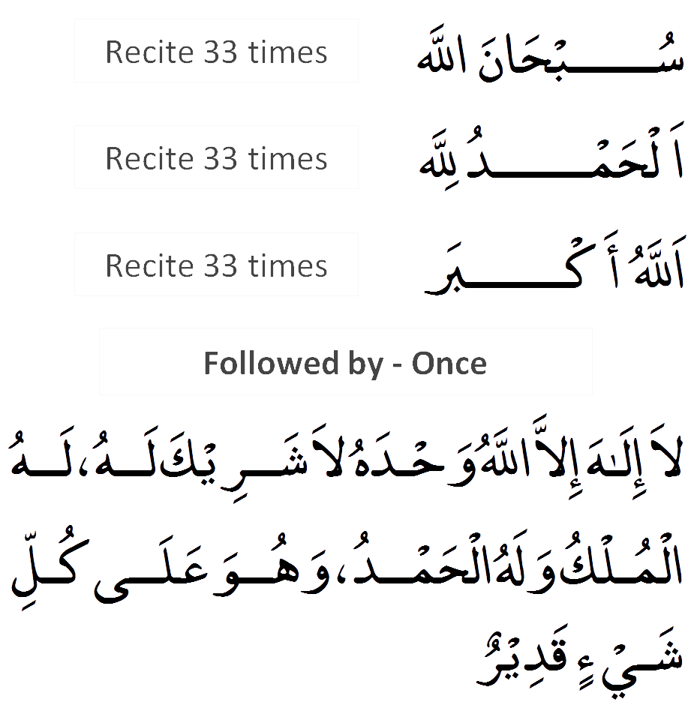
Sub-han Allah.
Alhamdu lillah.
Allah hu Akbar.
Laa ilaaha ill-allaahu, waḥdahu laa shareeka lahu, lahul-mulku wa lahul-ḥamdu, wa huwa ‛alaa kulli shay’in qadeer.
Glorious is God.
Praises are due to Allah.
Allah is the greatest.
None has the right to be worshipped except Allah, alone, without partner, to Him belongs all sovereignty and praise, and He is over all things omnipotent.
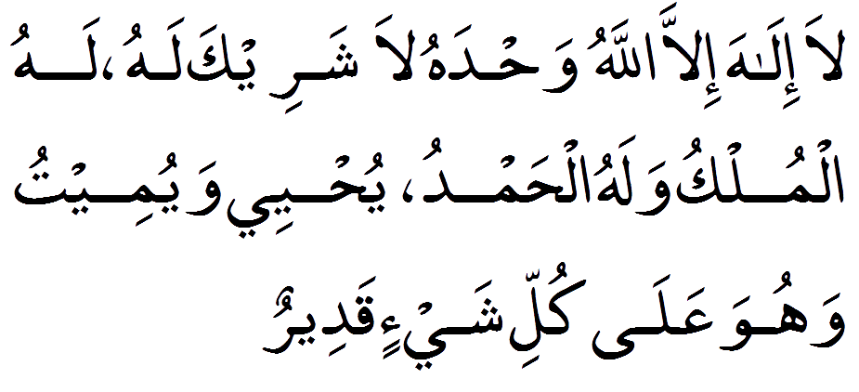
Laa ilaaha ill-allaahu, waḥdahu laa shareeka lahu, lahul-mulku wa lahul-ḥamdu, yuḥyee wa yumeetu, wa huwa ‛alaa kulli shay’in qadeer.
None has the right to be worshipped except Allah, alone, without partner, to Him belongs all sovereignty and praise, He gives life and causes death and He is over all things omnipotent.

6.Salat al Jumah:
Friday is called Yawm al-Jum’ah in Arabic, meaning the Day of Assembly. Muslims gather for congregational worship during the Friday midday prayer. Jum’ah is not a “sabbath” on which no work is done; rather, Muslims take just enough time off from work or school to attend a service at a neighborhood masjid. The Friday prayer is commanded by God in the Qur’an:
يَا أَيُّهَا الَّذِينَ آمَنُوا إِذَا نُودِيَ لِلصَّلَاةِ مِنْ يَوْمِ الْجُمُعَةِ فَاسْعَوْا إِلَىٰ ذِكْرِ اللَّهِ وَذَرُوا الْبَيْعَ ۚ ذَٰلِكُمْ خَيْرٌ لَكُمْ إِنْ كُنْتُمْ تَعْلَمُونَ
yā-ʾayyuhā lladhīna ʾāmanū ʾidhā nūdiya li-ṣ-ṣalāti min yawmi l-jumuʿati fa-sʿaw ʾilā dhikri llāhi wa-dharū l-bayʿa dhālikum khayrun lakum ʾin kuntum taʿlamūn.
O you who believe! When the call is made for prayer on Congregation Day, hasten to the remembrance of Allah, and drop all business. That is better for you, if you only knew.
The Friday prayer is exactly like the ritual prayers, or salat, performed during the rest of the week, except that on Friday the imam or prayer leader delivers a two-part sermon known as the khutbah, with a pause between the two parts of the sermon to allow for a time of personal prayer, or du’a. The imam usually reads and explains Qur’anic verses relevant to community concerns and encourages the congregation to remember their obligations to God and to each other, offering guidance and advice on how to live as a true Muslim in daily life.
Salatul Jumu’ah is an obligation upon every free, adult, sane, resident Muslim man who has the ability to attend the salah and does not have a valid excuse to miss it.

6-1.The Virtues of Friday:

- The Messenger of Allah ﷺ said: “Friday is the best of days. It was on this day that Hadrat Adam (peace be upon him) was created, it was on this day that he was granted entry into Paradise, it was on this day that he was removed from Paradise (which became the cause for man’s existence in this universe, and which is a great blessing), and the day of resurrection will also take place on this day.”
- The Messenger of Allah ﷺ said: “There is such an hour on Friday that if any Muslim makes dua in it, his dua will definitely be accepted.”
- The Messenger of Allah ﷺ said: “The Muslim who passes away on the night or during the day of Friday, Allah Most High saves him from the punishment of the grave.”
- Once Hadrat Ibn Abbas (Allah be pleased with him) recited the following verse:”This day, I have completed your Deen for you.” A Jew was sitting near him. On hearing this verse being recited he remarked: “If this verse was revealed to us, we would have celebrated that day as a day of eid.” Ibn Abbas (Allah be pleased with him) replied: “This verse was revealed on two eids, i.e. on the day of Friday and the day of arafah.” In other words, what is the need for us to make that day into a day of eid when it was already a day of two eids?
- The Messenger of Allah ﷺ used to say that the night of Friday is a lustrous night, and the day of Friday is a lustrous day.
- On one Friday, the Messenger of Allah ﷺ said: “O Muslims! Allah Most High has made this day a day of eid. So have a bath on this day, whoever has perfume should apply it, and use the miswaak.”

6-2.The respect of Friday:

- Every Muslim should make preparations for Friday from Thursday. After the asr prayer of Thursday, he should make a lot of istighfaar. He should clean his clothes and keep them ready.
- On the day of Friday, ghusl should be made and the hair of the head and the rest of the body should be thoroughly washed. It is also very virtuous to use the miswaak on this day.
- After making ghusl, a person should wear the best clothing that he possesses, and if possible he should also apply some perfume. He should also clip his nails.
- He should try and go very early to the congregational mosque. The earlier a person goes, the more reward he will receive.
- By going walking for the Friday prayer, one gets the reward of fasting for one year for every step that he takes.
- There is a lot of reward in reciting Surah Kahf either before the Friday prayer or after it. The Messenger of Allah ﷺ said: “the person who recites Surah Kahf on Fridays, a nur will appear for him from below the arsh as high as the skies. This light will help him in the darkness of the day of resurrection. And all the sins which he may have committed from the last Friday till this Friday will be forgiven.” (Sharh Sifrus-Sa’aadah) the ulama have written that this Hadith refers to minor sins because major sins are not forgiven without making taubah.

6-3.The Virtues and Importance of Friday Prayer:
Friday prayer is personally obligatory. It has been established from the Quran, Hadith and the consensus of the ummah. It is one of the most salient features of Islam. The person who rejects Friday prayer is a kaafir. The one who misses it without any valid excuse is a faasiq.
- The Messenger of Allah ﷺ said: “the person who has a bath on Friday, purifies himself as far as possible, applies oil to his hair, applies perfume, leaves for the mosque, when he arrives at the mosque he does not sit down by removing anyone from his place, offers as many nafl prayers as possible, when the imam delivers the khutbah he remains silent – then his sins from the previous Friday till now will be forgiven.”
- Hadrat Ibn Umar and Abu Hurayrah (Allah be pleased with them) a narrate that they heard the Messenger of Allah ﷺ saying: “People should abstain from leaving out Friday prayer. If not, Allah Most High will put a seal over their hearts whereby they will fall into severe negligence.”
- The Messenger of Allah ﷺ said: “the person who misses out three Friday’s without any valid reason, Allah Most High puts a seal over his heart.” In another narration it is mentioned that Allah Most High becomes displeased with him.
- Taariq bin Shihaab (Allah be pleased with him) narrates that the Messenger of Allah ﷺ said: “the Friday prayer with congregation is a duty which is necessary for every Muslim with the exception of the following four persons: (i) a slave, that is the one who is owned by someone according to the rules laid down by the Shariah, (ii) a woman, (iii) an immature boy, (iv) a sick person.”
- Hadrat Ibn Abbas (Allah be pleased with him) says that the person who leaves out several Friday prayers consecutively has in fact turned away from Islam.
Even by merely glancing at these Hadiths, one can come to the conclusion that the Shariah has laid great stress on Friday prayer and that severe warnings have been given to the one who leaves out Friday. Can a person who claims to be a Muslim still have the audacity of leaving out this fard duty?
6-4.The Method of Offering Friday Prayer:

1.After the first adhan of Friday and before the second adhan, four rakats of sunnah prayer should be offered. This sunnah is confirmed sunnah .
2. After the khutbah, two rakats fard Friday prayer should be offered with the imam.
3. Thereafter, four rakats sunnah should be offered. These are also a confirmed sunnah .
4. Thereafter, another two rakats should be offered. According to some ulama these two rakats are also confirmed sunnah .
5. Thereafter, another two rakats nafl should be offered.

6-5.Prerequisites which make Friday Prayer Necessary:

- To be a muqeem. Friday prayer is not necessary for a musafir.
- To be sound and healthy. Friday is not necessary for a person who is sick. That sickness which prevents a person from going to the congregational mosque on foot will be considered. If a person is very weak due to old-age, is unable to go to the mosque or is blind, then all these people will fall under the category of the sick and Friday prayer will not be necessary for them.
- To be a free person. Friday prayer is not necessary for a slave.
- To be a male. Friday prayer is not necessary for a female.
- To be free from those excuses which allow one from leaving out the congregation. These have been mentioned previously. If any of these excuses are found, Friday prayer will not be necessary. Examples:
- It is raining very heavily.
- One is taking care of a sick person.
- By going to the mosque there is a fear of a certain enemy.
- the prerequisites which we mentioned in order for prayer to be necessary are also considered here. That is, to be sane, mature, and to be a Muslim.
All these prerequisites which have been mentioned make Friday prayer necessary. If any of these prerequisites are not found in a person and he still offers Friday prayer, then his prayer will be valid. That is, the duty of offering Zuhr prayer will fall off. For example, a certain musafir or woman offers Friday prayer.
6-6.Prerequisites for the Friday Prayer to be Valid:

- The place has to be a city or town. Friday prayer is not valid in a village or jungle. However, Friday will be valid in a village if its population is equal to that of a town. For example, if there is a population of three to four thousand, Friday prayer will be valid.
- It has to be at the time of Zuhr. Friday prayer is not valid before Zuhr time or after the expiry of Zuhr. So much so, that if the Zuhr time expires while Friday prayer is being offered, then that prayer will become invalid even if the last sitting equal to the tashahhud has been completed. It is for this reason that qada is not made for Friday prayer.
- The khutbah has to be delivered. That is, to face the people and remind them of Allah Most High even if it means merely saying Sub’haanallah or Alhamdo lillah. However, it is makruh to suffice with this alone because it is contrary to the sunnah.
- The khutbah has to be before the prayer. If the khutbah is delivered after the prayer, the prayer will not be valid.
- The khutbah has to be delivered within the time of Zuhr. If the khutbah is delivered before the time of Zuhr, the prayer will not be valid.
- Congregation. That is, there has to be at least three persons apart from the imam who are present from the beginning of the khutbah till the prostration of the first rakaat. This is irrespective of whether those who were present for the khutbah are different from those who are present for the prayer. But this is on the condition that these three persons are such that they are eligible for imamate. Therefore, if there are only women or immature children, the prayer will not be valid.
- If the people go away before the prostration and less than three persons remain or no one remains, the prayer will become invalid. However, if they go after the prostration, the prayer will not be invalid.
- To offer Friday prayer openly and with full permission. It will not be permissible to offer Friday prayer in any private and secluded place. If Friday prayer is offered at such a place where the general public is not allowed to come or the doors of the mosque are closed at the time of Friday, the prayer will not be valid.If a person offers Friday prayer despite any of the above-mentioned prerequisites not being met, his prayer will not be valid. He will have to offer Zuhr prayer. Since this prayer of his will become a nafl prayer, and since nafl prayer is not offered with such preparations, in such a case it will be prohibitively disliked (makruh tahriman) to offer Friday prayer.

6-7.Rules for the Friday Khutbah:

- Once all the people have gathered together, the imam should sit on the minbar and the mu’azzin should call out the adhaan in front of him. Immediately after the adhan, the imam should stand up and deliver the khutbah.
- Twelve things are sunnah in the khutbah:
  - the person delivering the khutbah should be standing,
  - Two khutbahs should be delivered,
  - He must sit in between both the khutbahs to such an extent that Sub’haanallah could be recited three times,
  - He must be pure from major ritual impurity (hadath akbar) and minor ritual impurity (hadath asghar),
  - While delivering the khutbah, he must face the people,
  - He must recite A’udhu billahi minash shaytaanir rajeem in his heart before commencing with the khutbah,
  - He must deliver the khutbah in such a way that all the people can hear his voice,
  - the subject matter of the khutbah must comprise of the following eight things:
    - gratitude to Allah Most High,
    - praise to Allah Most High,
    - testifying the Oneness of Allah Most High and the prophethood of the Messenger of Allah ﷺ.
    - salutations to the Messenger of Allah ﷺ.
    - admonition and advice,
    - recitation of verses or a Surah from the Quran,
    - to repeat all these things in the second khutbah as well,
    - to make dua for the Muslims instead of giving advice and admonition in the second khutbah. This was a list of the subject matter.
We will now go back to those factors which are sunnah for the khutbah itself.
  - the khutbah should not be too lengthy. Instead, it should be shorter than the prayer.
  - To deliver the khutbah from the minbar. If there is no minbar, one should stand up by taking support from a staff or rod. To take support from a staff or rod or to place one hand over the other while one is on the minbar, which is the habit of some people; has not been reported.
  - Both the khutbahs have to be in Arabic. To deliver the khutbah in any other language or to add any poetry or idioms of another language as is prevalent today at some places is contrary to confirmed sunnah (sunna mu’akkada) and is in fact prohibitively disliked (makruh tahriman).
  - Those listening to the khutbah should face the qiblah.
In the second khutbah it is recommended (mustahabb) to make dua for the Messenger of Allah’s ﷺ family, companions, wives, and specifically for the khulafaa-e-raashidin and Hadrat Hamzah and Abbas (Allah be pleased with them). It is also permissible to make dua for the leader of the Islamic state. But it is prohibitively disliked (makruh tahriman) to praise him for things which are not true.
- Once the imam stands up to deliver the khutbah, it is prohibitively disliked (makruh tahriman) to offer any prayer or to speak with each other. However, it is permissible for the saahib-e-tarteeb to offer his qada prayer at that time. In fact, it is necessary for him to offer his qada prayer. As long as the imam does not complete his khutbah, all these things will be prohibited.
- Once the khutbah commences, it is necessary for all those present to listen to the khutbah. This is irrespective of whether they are sitting near the imam or far away from him. It is also prohibitively disliked (makruh tahriman) to do such a thing which will distract one from listening. Just as eating, drinking, talking, walking, making salaam, answering to a salaam, reading some tasbeeh, showing someone a masa’ala of the Shariah is prohibited while one is in prayer, it is also prohibited while the khutbah is being delivered. However, it is permissible for the one who is delivering the khutbah to show a issue of the Shariah while he is delivering his khutbah.
- If the khutbah commences while one is offering one’s prayer, it is better to complete it if it is confirmed sunnah (sunna mu’akkada). If it is a nafl prayer, one should make salaam after two rakaats.
- It is prohibitively disliked (makruh tahriman) for the muqtadis as well as the imam to raise their hands and make dua in-between the two khutbahs when the imam is sitting. However, it is permissible to make dua in one’s heart without raising one’s hands as long as one does not say anything with one’s tongue – neither silently nor loudly.Nothing has been related from the Messenger of Allah ﷺ and his companions with regard to delivering khutbahs on the last Friday of Ramadan which contain matters related to the departure of Ramadan. Nor is there any mention of this in the books of Islamic jurisprudence. In doing so, there is the danger of the masses thinking that this is necessary. It is therefore a bid’ah. Note: these days undue attention is given to this sort of khutbahs. If anyone does not deliver such khutbahs, he is accused and mocked at. Special preparations are made in listening to such khutbahs.
- It is permissible to deliver a khutbah while looking into a book.
- If the Messenger of Allah’s ﷺ name is mentioned in the khutbah, it is permissible for the muqtadis to send blessings to him in their hearts.

6-8.Rules Related to Friday Prayer:

- It is preferable that the person who delivers the khutbah also performs the prayer. However, it is permissible for someone else to perform the prayer.
- It is sunnah to call out the iqaamah and commence with the prayer immediately after the completion of the khutbah. It is prohibitively disliked (makruh tahriman) to engage in any worldly activity between the khutbah and the prayer. If there is a very lengthy gap between the khutbah and the prayer, it will be necessary to repeat the khutbah. However, if the delay is caused because of a Deeni reason, e.g. To show someone a issue, or the wudu of the imam broke and he went to make wudu, or after delivering the khutbah he realized that he had to have a bath, so he went to have a bath – in all these cases it will not be makruh nor will it be necessary to repeat the khutbah.
- Friday prayer should be offered with the following intention: “I intend offering two rakaats fard of Friday prayer.”
- It is preferable for all the people to get together and offer Friday prayer in one mosque. However, it is permissible for the people of one place to offer their Friday prayer in several mosques.
- If a person joins the prayer in the last sitting at the time of reciting the at-tahiyyaat or after prostration-e-sahw, his joining the congregation will be correct and he will have to complete his Friday prayer. He will not have to offer Zuhr prayer.
- Some people offer Zuhr prayer after the Friday prayer as a precaution. Since the belief of the masses has become corrupted in this regard, they should be strictly stopped from this. However, if a knowledgeable person wishes to offer the Zuhr prayer due to some doubt, he should do so without letting anyone come to know of it.

7.The Prayer Of A Travelling Person:

Islam is a religion full of mercy and because of the hardships and inconveniences which a person usually undergoes during travels, Allah (subhanahu wa ta'ala) has made certain concessions to the traveler. One of these concessions is that traveler may shorten some of the obligatory prayers.

Because of this grant from Allah (subhanahu wa ta'ala), it is an established
practice that a traveling Muslim may shorten the four (4) rakaats obligatory prayers into two rakaats only. Thus, the Dhuhr, Asr and lsha prayers may each be shortened into two rakaats. However, the Maghrib and the Fajr prayers cannot be shortened and are to be performed in full.

It is also an established practice that the traveler may combine some of the
obligatory prayers. Thus, the Dhuhr prayer may be delayed until the time of the Asr prayer when both will be performed; or, the Asr prayer may be brought forward to the time of the Dhuhr prayer when both will be performed.

Likewise, the Isha prayer may be brought forward to the time of Maghrib prayer; or, the Maghrib prayer may be delayed until the time of Isha prayer.

The Fajr prayer can neither be brought forward or delayed and has to be performed at its prescribed time.

7-1.Characteristics of combining the prayers:

1. Each prayer will be performed separately.
2. Only one Prayer Call (ADHAN) shall be made for both prayers but two Second Calls (IQAMAHS) shall be required (i.e. one Second Call (Iqamah) shall be made separately for each prayer).

If we may give an example, assuming that a traveler wishes to combine Dhuhr and Asr prayers by bringing the Asr prayer forward to the time of the Dhuhr prayer, the person would proceed as follows:

I. The person would first come up with the Call for prayer "Adhaan" intending it for both the two prayers.
II. The person would then come up with the second call "Iqamah" for the Dhuhr prayer.
III. The person would then perform the Dhuhr prayer shortening it to two rakaats only.
IV. After completing the Dhuhr prayer, the person stands up and makes another second call "Iqamah" for the Asr prayer.
V. The person would then perform the Asr prayer also shortened to two rakaats only.

Note: A traveler may lead the prayer as an "IMAM" of the residents of the place he is visiting. And in such a case, he (being an Imam), may perform only two rakaats for the Dhuhr or Asr, and/or Isha prayers while, the residents he is leading, shall upon his completion continue to complete the remaining two rakaats of the respective prayers.

However, in such cases, it is desirable that the traveler who may act as an Imam first gives notice to the congregation regarding his position and his intention to shorten his prayer so that the congregation continues to complete the prayer.

On the other hand, if the traveler has to pray behind an Imam who is a resident of the place he is visiting, then in such case, the traveler shall pray with the Imam all the four (4) rakaats as usual.

7-2.What to do when you miss Salah:

If you miss a prayer you have to make it up as soon as you wake up or remember. Prayers must be made up in chronological order.

For example, if you missed Asr prayer, and it is now Maghrib time, then you must pray Asr first, then Maghrib.
8.Eid Salah:
Eid Salah is a special prayer that commemorates the end of Ramadan on the day of Eid ul-Fitr and the sacrifice of Prophet Abraham on the day of Eid ul-Adha. Muslims all around the world perform this salah twice a year, and the method is different from the daily prayers. This prayer is normally offered in an open space, like a large field, rather than in a mosque. All male Muslims are required to perform Eid Salah, and female Muslims are encouraged to attend, though they must observe hijab and other mosque ordinances.

1. Pay Sadaqat-ul-fitr to the poor if you are a well-off Muslim. This is generally paid in the form of food, like rice, barley, and dates. This is an obligation for both male and female Muslims that enables all Muslims to celebrate Eid ul-Fitr and Eid ul-Adha. If you are an adult and have dependent children, you also need to give something in the name of your child.

Sadaqat-ul-fitr is given to the poor so that they don’t have to worry about earning money on the day of the Eid Salah and can thus participate in the prayer along with everyone else.
If you are married, you and your spouse need to pay Sadaqat-ul-fitr individually and not combined as a couple.
2. Arise early and bathe yourself the morning of Eid Salah. Brush your teeth, wash your body, put on perfume, and wear your finest clothes to prepare yourself for Eid Salah. Take special care to look your most presentable. If you can, wear new clothes or ones that you only wear on special occasions.
3. Eat an odd number of dates before heading to the Eid ul-Fitr prayer. It’s customary to eat something sweet before going to perform Eid Salah, and the odd number is important because that is how the Prophet broke his fast the morning of Eid ul-Fitr.
4. The time for Eid Prayer is when the sun has risen about three meters (10 feet) above the horizon. Eid Prayers cannot be said after midday. It is better to hold Eid Prayers in the open if there is no rain or bad weather. The Prophet never performed Eid Prayers in the mosque except once due to rain.
5.There is neither Adhan (call to prayer) nor Iqamah (second call to prayer) for these prayers, which consist of two rak`ahs with twelve takbirs (Allahu Akbar); seven in the first rak`ah and five in the second. After performing prayer, the imam delivers a khutbah (sermon, speech) just like Friday khutbah.
6.The loud chanting of Takbir of Eid is one of the greatest sunnahs of this day. They are to be recited loudly and in unison by everyone attending Eid Prayer and everyone on their way there. This show of power enforces the feeling of unity and solidarity and declares the joy of Eid to all.

اَللهُ أكْبَرُ اَللهُ أكْبَرُ، لاَ إِلهَ إِلاَّ اللهُ وَاللهُ أكْبَرُ، اَللهُ أكْبَرُ وَلِلّهِ الْحَمْد

"Allahu Akbar, Allahu Akbar, la Ilaha illa Allah; Allahu Akbar, Allahu Akbar, walillah al-hamd".
Allah is the Greatest, Allah is the Greatest. There is no god but Allah; Allah is the Greatest, Allah is the Greatest, and all praise is due to Allah.

7. Stand and greet your neighbors at the end of Eid Salah. This is the end of the Eid Salah. Say hello and give good wishes to your neighbors, and then head to your celebration. Many families have large feasts and give presents on Eid Salah.
This is also a great time to get together with extended family. Eid Salah is only performed twice a year, so it’s a special occasion!

8-1.How to Offer Eid-ul-Adha Salat:
In general, when praying any Salah, always follow the Imam in prayer. Do not make your movements (i.e. bowing, prostrating, etc.) before he does or different from him.
Eid prayer consists of two units (Rakat in Arabic, singular is Raka). The main difference in the way this prayer and any other prayer of two Rakat is performed is the number of Takbirs that are done.

1 Rakat.
1.First make the Niyyah (intention) by reciting "I intend to doing two Rakat behind the Imam for Eid prayer along with six additional Takbeers.
2.Follow the Imam by raising both hands up to the ears, say "Allahu Akbar", this is the first Takbir to enter in the Salat.
3.Begin reciting "Subhanaka".
4.Takbeer, Say "Allahu Akbar" (with the imam), then let the hands down.
5.Takbeer, Say "Allahu Akbar" (with the imam), then let the hands down
6.Takbeer, Say "Allahu Akbar" (with the imam), then clasp the hands, listen to the imam reciting the Fatiha and a surah. After the Imam completed the Fatiha you quietly say "Ameen".
7.Go into Ruku (the bowing position) and You say "Subahaana Rabbiyal Azeem"3 Tmies or more.
8.Stand up straight when he says "Sami Allahu liman Hamidah", and say "Rabbana lakal Hamd" in a low voice.
9.Go into the 1st Sajdah and You say "Subahaana Rabbiyal Aa'la"3 Tmies or more.
10.Now sit-up from the first Sajdah in jalsa position (Sitting position between the two Sajdahs)
11.Now go into the 2nd Sajdah and You say "Subahaana Rabbiyal Aa'la"3 Tmies or more.

2. Rakat.

12.Rise up to proceed to the next raka'at,
13.In the second rakaat imam will first recite Surah Fatiha and some other Surah.
14.Takbeer, Say "Allahu Akbar" (with the imam), then let the hands down.
15.Takbeer, Say "Allahu Akbar" (with the imam), then let the hands down.
16.Takbeer, Say "Allahu Akbar" (with the imam), then let the hands down.
17.Takbeer, Say "Allahu Akbar" (with the imam), then Go into Ruku (the bowing position) and You say "Subahaana Rabbiyal Azeem" just after the fourth takbeer (Without removing the hands) 3 Tmies or more.
18.Stand up straight when he says "Sami Allahu liman Hamidah", and say "Rabbana lakal Hamd" in a low voice.
19.Go into the 1st Sajdah and You say "Subahaana Rabbiyal Aa'la"3 Tmies or more.
20.Now sit-up from the first Sajdah in jalsa position (Sitting position between the two Sajdahs).
21.Now go into the 2nd Sajdah and You say "Subahaana Rabbiyal Aa'la"3 Tmies or more.
22.After this, you sit for the complete Tashshahud: You recite At-tahiyyat, Allah-umma salli, Allah-umma Barik and Rabbana.
23.Turning to your face to the right first and saying "Assalamu alaikum wa Rahmatullah" and then to his left and doing the same.
24.Do not get up right away. The Imam will give a short Khutbah (speech). Please stay still and listen. It is recommended to do so.

9.Salat-e-Janaza (Funeral prayer):
The Muslims of the community gather to offer their collective prayers for the forgiveness of the dead. This prayer has been generally termed as the Namaze Janaza.The prayer is offered in a particular way with extra (four)Takbirs but there is no Ruku ( bowing ) and Sijdah (prostrating) It becomes obligatory for every Muslim adult male to perform the funeral prayer upon the death of any Muslim, however when it is performed by the few it will not be obligation for all.
9-1.Principles of Janazah:
1) Some people pray while wearing shoes and many people pray Janzah while standing on the shoes. If one prays wearing the shoes then it is necessary that the shoes and the earth underneath be pure and if one stands on the shoes then it is necessary that the shoes be pure.
2) There is more ihtiyat (care) that one does not pray while standing on the shoes. Stand on the earth, if you want you can stand upon your handkerchief.
3) It is necessary for the body of the deceased to be present; the janzah of the absent is not permissible
4) It is mustahab that the Imam stand in front of the chest of the deceased.
5) Several janzah maybe prayed at the same time; there is the option of putting the deceased in a row so that the chest of all is in front of the imam or in a line so that ones’ head is in line with the other’s feet and the others’ feet is in line with the others’ head.
6) It is better to make three saf (rows) as it is mentioned in the Hadith that, “Whosevers’ salatul janzah was read by three saf, they will be forgiven.”
7) If there are, for example, seven people, then one should become the Imam, three people should stand in the first saf, two in the second saf, and one in the last saf.
8) In Janzah, the last saf is the best out of all the saf.
9) Masbooq, one who missed some takbeer, should say the rest of his takbeer after the Imam says salaam, and he should say only the takbeer without the supplicatoins if he fears that people while start to give shoulder to the janzah before he finishes all the supplications.
10) One can join the janzah even after the fourth takbber until the Imam has not said salaam. After the salaam of the Imam, he should say Allahu Akbar thrice and say salaam.
11) The duaa for a boy or girl will be read for whoever died in a condition of madness in which they were born in or madness which occurred before puberty and lasted until death.
12) There is Gusul, Kafan, and Janzah for the child of a muslim whose akhtar (most) body had come out otherwise the child will be bathed, covered in sheet, and buried without gusul, kafan and salah. Akthar (most), from the head, means from the head to the chest; so there is no janzah for the child who was born crying from the head but passed away before the chest came out, and from the feet, akthar means from the feet to the back. A child born alive or dead will be given a name and on the day of Qayamat the child will be resurrected.
9-2.The Order of Going with the Janzah Procession:
1.It is an act of ibadat to give shoulder to a janazah.
2. It is sunnat to give shoulder to all four legs ten steps each in such a manner that one shoulders the top head-right first, bottom leg-right second, then top head-left third, and then bottom-leg left last making a total of forty steps.
3) There is no harm if one person holds a small child in his arms and people hold the deceased one after the other.
4) It is not permissible nor allowed for ladies to go with the Janzah.
5) One should not return without praying the Janzah if he is with the Janzah, and he may return after the prayer with the permission of the awliyae mayyat and there is no need for permission after the burial.
6) A husband may shoulder his wife’s janazah, lower it into the grave, and see the face. He may not give his wife gusul or touch her without anything between the body. The wife may give her husband gusul.
9-3.Method of Namaze Janaza:
1.Intention : I intend to offer for Allah, four takbirs of funeral salat, with my praise for Allah and darood for Rasullah and prayer for this deceased person. I adopt Imam as leader and I face towards Ka`ba. The Imam makes the same intention.
2. The prayer begins with first takbir of Allaho Akbar by Imam , [The Imam must say all the takbeer aloud whereas the muqtadee (followers) must repeat them silently.

اللهُ أكبر Allahu Akbar (Allah is the Greatest)

When first takbir is said by Imam the followers should repeat the takbir silently and lift both the hand up to the ears, palm facing Qibla and keep the hands under the navel, right hand on top of left. Then recite sana with addition of one word :

Subhana kalla humma ,wabe hamdeka ,wata baara kasmoka ,wata aalaa jaddoka, wa jalla sanaoka,wala ilaha gairoka.

Glory be to You Oh Allah, and praise be to You, and blessed is Your name, and exalted is Your Majesty, and there is none to be served besides You.

3.The Imam Say the second takbir of Allaho Akbar,which is followed by the followers ,this time no need of raising the hands.

اللهُ أكبر Allahu Akbar (Allah is the Greatest)

4.Then recite both (Imam and followers) the Durood Sharif.
Allah humma salle ala Mohammadiun wa ala aale Mohammadin kama sallaita ala Ibrahima wa ala aale Ibrahima innaka Hamidum Majeed.
Allah humma Barik ala Mohammadiun wa ala aale Mohammadin kama baarakta ala Ibrahima wa ala aale Ibrahima innaka Hamidum Majeed.
O Allah! send grace and honor on Mohammad and on the family and true followers of Mohammad just as you sent Grace and Honor on Ibrahim and on the family and his true followers. Surely, you are praiseworthy, the Great."
"Oh Allah, send your blessing on Mohammad and the true followers of Mohammad just as you sent blessings on Ibrahim and his true followers. Surely you are praiseworthy, the Great."

5.The Imam Say Allaho Akbar, as the third takbir and is followed by the followers in the same way as it was done at the time of second takbir.

اللهُ أكبر Allahu Akbar (Allah is the Greatest)

then recite following dua silently.

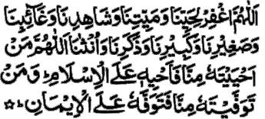
Allah hummag fir le hayyena, wa mayyetena, wa shaaedena, wa gaaebena, wa sagheerena, wa kabirena ,wa zakarena ,wa unsana , Allah humma man aah yaiytahu , minna fa aah yehi alal Islam .Waman tawaf faiytahu minna fata waffahu alal Iman.

Oh Allah! Forgive those of us who are alive and those of us who are dead; those of us who are present and those of us who are absent; those of us who are young and those of us who are adults; our males and our females. O`Allah! Whomsoever You keep alive, let him live as a follower of Islam and whomsoever You cause to die, let him die as a Believer.

6.The Imam say the takbir of Allaho Akbar ,as the fourth takbir, the followers also repeat the same silently.

اللهُ أكبر Allahu Akbar (Allah is the Greatest)

7.Then both salutation on right and then left.

اَلسَلامُ عَلَيْكُم وَرَحْمَةُ اَللهِ وَبَرَكاتُهُ‎, اَلسَلامُ عَلَيْكُم وَرَحْمَةُ اَللهِ وَبَرَكاتُهُ‎
as-salāmu ʿalaykum wa-raḥmatu llāhi wa-barakātuhu,
as-salāmu ʿalaykum wa-raḥmatu llāhi wa-barakātuhu.
(peace and the mercy of Allah be on you), (peace and the mercy of Allah be on you).

This ends the Namaze Janaza for adults.

9-4.Minor Person:

If the dead person is a minor, the funeral Dua is different for the male and different for the female: Upto 3rd Takbir the Namaz is same , thereafter the dua is different :

1.Dua for male child is as under :

Allahummaj alho lana faratau waj alho lana ajrau wa zukhrau waj alho lana shafe au wa Mushaffa an.

Oh! Allah, make him (this child) for our means of preservation and make him a source of reward and treasure for us and make him a pleader for us and one whose pleading is accepted.

2.Dua for Female child is as under :

Allahummaj alha lana faratau waj alha lana ajrau wa zukhrau waj alha lana shafe au wa Mushaffa an .

Oh! Allah, make her (this child) for our means of preservation and make her a source of reward and treasure for us and make her a pleader for us and one whose pleading is accepted.

10.Salat al-Ishraq (Post-Sunrise Prayer):

Salat al-Ishraq (Post-Sunrise Prayer) Ishraq Prayer is a nafl prayer which is performed about 45 minutes (three quarters) after sunrise (according to the Hanafi school of thought) or 20 minutess after sunrise (according to the Shafi school).

Salah al-Ishraq is performed when a person has read Fajr with congregation and then stays at his place of prayer engaged in Zikr until the sun appears fully, about twenty minutes after sunrise. He then reads two Rakats nafl prayer of Ishraq.

A person prays between 2 and 12 units of prayers in multiples of 2. After completing Fajr salat, one does not move from one’s place and remains there reciting dhikr, tasbih, Qur’an, etc., avoiding participation in worldly affairs until the sun has fully risen (about 20 minutes after sunrise). Then, one stands and offers two or four rakat of nafl. Hadiths are replete with the high merits of this prayer.

Abu Hurairah (radiAllahu anhu) relates that the Prophet ﷺ has said that "He who says Ishraq prayers without fail shall have his lesser sins forgiven even though they may be as numerous as foam specks on the surface of the sea."

Rasul Allah ﷺ is reported to have said that Allah Ta'ala says, 'O son of Adam, perform 4 Rakats of Salat (Ishraq) in the early part of the day. I shall help you in accomplishing all your responsibilities during the rest of the day.'
In another narration of at-Tirmidhi, Rasul Allah ﷺ is reported to have said, 'He who performs Fajr Salat with Jamaat and remains seated in the same place while engaging in Dhikr until after sunrise and thereafter performs 2 Rakats Nafil Salat, (Ishraq), he will obtain the reward of one Hajj and one Umrah.'

11.Salatul Duha (Chaasht):
The beloved Prophet ﷺ has said: For the one that has read the 12 Raka-at Salatud Duha, Allah will build for him a golden castle in paradise, and the one that always reads the 2 Raka-ats of Chaasht will have his sins forgiven even though they may be of oceanic dimensions.

The prayer of Chaasht consists of 2 Raka-at and of a maximum of 12 Raka-ats. It should be read between the time the sun has completely risen from the horizon and before Zawal (zenith of the sun).
The Prophet ﷺ said: “whoever prays Salat-ul-Fajr in Jammah could stay in the Masjid glorifying Allah until after the sunrise. Then if stands up and pray two rakah (Nafela called Al-duha), he will have the reward of performing a complete Haj and Umrah with me…” and the Prophet ﷺ repeated, “complete, complete, complete". This can also be done in your house, Insha’Allah, you will have the same reward.
12.Salatul Awwabeen:
This Nafil prayer is read after the Farz (Fard) and Sunnat of Maghrib. It consist of a minimum of 6 Raka-ats and this Nafil prayer procures many benedictions (blessings) and mercy.

13.Prayer of Tahajjud:
Our Master, the beloved Prophet Muhammad ﷺ has said: In Paradise there is a castle reserved for those who read Tahajjud and the Prophet ﷺ further adds, those who pray at night will enter paradise without having to account for their acts in this life.
The Nafils of Tahajjud are read after the Esha prayer, but it is important to sleep before performing Tahajjud. The prayer consists of a minimum of 2 Raka-ats, and a maximum of 8 or 12 Raka-ats (to be read according ones capacity). With the performance of 2 Rakats you have duly achieved your Tahajjud. However, the performance of 8 Rakats in Sunnat, and complying with the practice of the Holy Saints of Islam and performing 12 Rakats is commendable.

After Esha prayers sleep for some time, then wake up any time during the night before the rise of morning for Tahajjud prayers.

It is recommended that you recite in your prayers as much of the Sacred Quran as you know. If you happen to know by heart the whole of the Sacred Quran you may, in at least 3 nights or most 4 nights of Tahajjud effectuate the complete reading of the Sacred Quran.
Otherwise, you may recite 3 Surah Ikhlas (Qul Hu Allahu Ahad) after your "Alhamdu..." in every Rakat and you will thus derive full benefits of the full recital of the Sacred Quran in every Rakat.
14.Salatul Tasbih:
Our beloved Prophet ﷺ had taught this Nafil prayer to his Uncle, Hazrat Abbas (RA) and told him; He who performs this prayer will have his past and future sins forgiven. The Prophet ﷺ has recommended to read this prayer daily on each Friday or once a month or once a year, in case of this not being possible, to read it even once in one’s life. This Nafil prayer provides limitless benefits both in the material and spiritual life.

14-1.How to perform Salatul Tasbih:
The Tasbih to be read in Salaat-Ul-Tasbeeh:
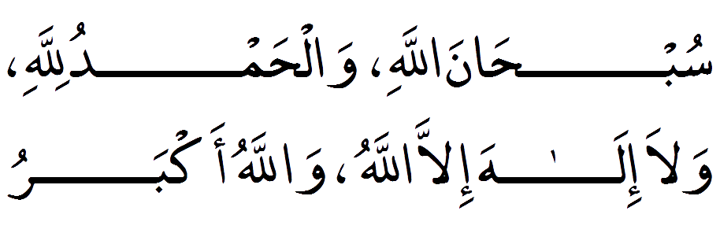
Subhana’l Llah wa’l-hamdu li’l Llah wa la ilaha illa’l Llah wa’l Llahu akbar.
Glory be to Allah, All Praise is for Allah, There is No God but Allah, Allah is the Greatest.

1. Rakat.
1.First make the Niyyah (intention) by reciting "I intend to perform four rakats of the Salatul Tasbeeh"
2.You say takbir "Allahu Akbar" This starts the prayer.
3.Begin reciting "Subhanaka" After reading the Thana(Sana) Recite the above tasbeeh 15 times.
4.After you say: "Audhu billahi min-ash-shayta -nir-rajeem Bismillah-ir-Rahman-ir-raheem"
5.Reciting Surah Al Fatiha
6.Another portion (Surah) of the Qur'an. After this Recite the above Tasbeeh 10 times.
7.Then go into Ruku (the bowing position) and after Tasbeeh (Subahaana Rabbiyal Azeem) Recite the above Tasbeeh 10 times
8.Go to Qowmah (standing position after Ruku ) and after saying samee Allaahu Liman Hamidah, Rabbana Lakal Hamdh, Then Recite the above Tasbeeh 10 times.
9.Go into the 1st Sajdah and after the tasbih (Subahaana Rabbiyal Aa'la) Recite the above Tasbeeh 10 times.
10.Now sit-up from the first Sajdah in jalsa position (Sitting position between the two Sajdahs) and then Recite the above Tasbeeh 10 times.
11.Now go into the 2nd Sajdah and after the tasbeeh (Subahaana Rabbiyal Aa'la) Recite the above Tasbeeh 10 times.
2. Rakat.
12.Rise up to proceed to the next raka'at, After reading the Thana(Sana) Recite the above tasbeeh 15 times.
13.You say "Bismillah-ir-Rahman-ir-raheem"
14.Reciting Surah Al Fatiha
15.Another portion (Surah) of the Qur'an. After this Recite the above Tasbeeh 10 times.
16.Go into Ruku (the bowing position) and after Tasbeeh (Subahaana Rabbiyal Azeem) Recite the above Tasbeeh 10 times
17.Go to Qowmah (standing position after Ruku) and after saying samee Allaahu Liman Hamidah, Rabbana Lakal Hamdh, Then Recite the above Tasbeeh 10 times.
18.Go into the 1st Sajdah and after the tasbih (Subahaana Rabbiyal Aa'la) Recite the above Tasbeeh 10 times.
19.Now sit-up from the first Sajdah in jalsa position (Sitting position between the two Sajdahs) and then Recite the above Tasbeeh 10 times.
20.Now go into the 2nd Sajdah and after the tasbeeh (Subahaana Rabbiyal Aa'la) Recite the above Tasbeeh 10 times.
21.After this, you sit for Tashshahud: You recite just At-tahiyyat, Allah-umma salli, Allah-umma Barik and Rabbana
3. Rakat.
22.Begin reciting "Subhanaka" After reading the Thana(Sana) Recite the above tasbeeh 15 times.
23.After you say: "Audhu billahi min-ash-shayta -nir-rajeem Bismillah-ir-Rahman-ir-raheem"
24.Reciting Surah Al Fatiha
25.Another portion (Surah) of the Qur'an. After this Recite the above Tasbeeh 10 times.
26.Go into Ruku (the bowing position) and after Tasbeeh (Subahaana Rabbiyal Azeem) Recite the above Tasbeeh 10 times
27.Go to Qowmah (standing position after Ruku ) and after saying samee Allaahu Liman Hamidah, Rabbana Lakal Hamdh, Then Recite the above Tasbeeh 10 times.
28.Go into the 1st Sajdah and after the tasbih (Subahaana Rabbiyal Aa'la) Recite the above Tasbeeh 10 times.
29.Now sit-up from the first Sajdah in jalsa position (Sitting position between the two Sajdahs) and then Recite the above Tasbeeh 10 times.
30.Now go into the 2nd Sajdah and after the tasbeeh (Subahaana Rabbiyal Aa'la) Recite the above Tasbeeh 10 times.
4. Rakat.
31.Rise up to proceed to the next raka'at, After reading the Thana(Sana) Recite the above tasbeeh 15 times.
32.You say "Bismillah-ir-Rahman-ir-raheem"
33.Reciting Surah Al Fatiha
34.Another portion (Surah) of the Qur'an. After this Recite the above Tasbeeh 10 times.
35.Go into Ruku (the bowing position) and after Tasbeeh (Subahaana Rabbiyal Azeem) Recite the above Tasbeeh 10 times
36.Go to Qowmah (standing position after Ruku) and after saying samee Allaahu Liman Hamidah, Rabbana Lakal Hamdh, Then Recite the above Tasbeeh 10 times.
37.Go into the 1st Sajdah and after the tasbih (Subahaana Rabbiyal Aa'la) Recite the above Tasbeeh 10 times.
38.Now sit-up from the first Sajdah in jalsa position (Sitting position between the two Sajdahs) and then Recite the above Tasbeeh 10 times.
39.Now go into the 2nd Sajdah and after the tasbeeh (Subahaana Rabbiyal Aa'la) Recite the above Tasbeeh 10 times.
40.After this, you sit for the complete Tashshahud: You recite At-tahiyyat, Allah-umma salli, Allah-umma Barik and Rabbana.
41.By turning to your face to the right first and saying "Assalamu alaikum wa Rahmatullah" and then to his left and doing the same
For each Raka'at with the Tasbeeh been prayed 75 times.
Note: No fixed time has been prescribed for this prayer, a fact, which means that besides any time prohibited this prayer, can be read at any time.
15.Salatul Hajaat:
In case of difficulty, illness or of authorized necessity this prayer is read. The beloved Prophet ﷺ had taught this to a blind person who, as soon as he performed it, regained his eyesight.

To perform this prayer it is recommended to wear one’s best and clean clothes and to perform pleasingly one’s ablution (Wudu). Then 2 Raka-at Nafil is read in the usual way, after salaam this dua is read:

لاَ إِلَهَ إِلاَّ اللَّهُ الحَلِيمُ الكَرِيمُ، سُبْحَانَ اللهِ رَبِّ العَرْشِ العَظِيمِ، الحَمْدُ لِلَّهِ رَبِّ العَالَمِينَ، أَسْأَلُكَ مُوجِبَاتِ رَحْمَتِكَ، وَعَزَائِمَ مَغْفِرَتِكَ، وَالغَنِيمَةَ مِنْ كُلِّ بِرٍّ، وَالسَّلاَمَةَ مِنْ كُلِّ إِثْمٍ، لاَ تَدَعْ لِي ذَنْبًا إِلاَّ غَفَرْتَهُ، وَلاَ هَمًّا إِلاَّ فَرَّجْتَهُ، وَلاَ حَاجَةً هِيَ لَكَ رِضًا إِلاَّ قَضَيْتَهَا يَا أَرْحَمَ الرَّاحِمِينَ

Lā ilāha illallāhul-halīmul-karīm subhānallāhi rabil-a’rshil-a’dhīm al-hamdu lillahi rabil-ā’lamīn asaluka mūjibāti rahmatik wa a’zāima maghfiratik wal-ghanīmata min kulli birr was-salāmata min kulli ithm lā tada’ lī dhamban illā ghafartah wa lā hamman illa farrajtah wa lā hājatan hiya laka ridhan illa qadhaytahā yā arhamar-rāhimīn
There there no god but Allah the Clement and Wise. There is no god but Allah the High and Mighty. Glory be to Allah, Lord of the Tremendous Throne. All praise is to Allah, Lord of the worlds. I ask you (O Allah) everything that leads to your mercy, and your tremendous forgiveness, enrichment in all good, and freedom from all sin. Do not leave a sin of mine (O Allah), except that you forgive it, nor any concern except that you create for it an opening, nor any need in which there is your good pleasure except that you fulfill it, O Most Merciful!
(Or read).
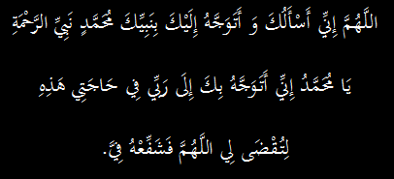

Allahuma Inni As-aloka wa (Atawassalo) Wa Atawajjaaho ilaika be nabbiyeka Muhammadin nabi yir Rahmate ya Rasullulah. Inni tawajjahto be ka ila Rabbi fi hajaati haa-zehi (here we make our requests (le tuqza li) Allahumma fashaffiho fiya.

O Allah I implore You and I come near You through the intermediary of Your Prophet (Nabee) Muhammad (sallal laahu alaihi wasallam) who is the Prophet of Grace. Ya Rasullullah, through your intercession I implore Allah to accept my request. O Allah grant the intercession of your Prophet (sallal laahu alaihi wasallam) in my favor.

16. Salat al-Istikharah:
"The Messenger of Allah (peace and blessings of Allah be upon him) used to teach his companions to make Istikharah in all things, just as he used to teach them Surahs from the Qur'an. He (SAW) said: 'If any one of you is concerned about a decision he has to make, (or in the version narrated by Ibn Mas'ood as: 'if any one of you wants to do something...) then let him pray two rak'ahs of non-obligatory prayer and say (after the Salah).
16-1.A translation of the supplication is as follows:
"O Allah, I seek Your counsel by Your knowledge and I seek Your assistance by Your power and I ask You from Your immense favour, for verily You are able while I am not, and verily You know while I do not, and You are the knower of the Unseen. O Allah, if You know this affair ( mention affair here ) to be good for me in relation to my religion, my life and aftermath, my present and future, then decree it and facilitate it for me, and bless me with it, and if You know this affair to be ill for me concerning my religion, my life and end, my present and future, then remove it from me and remove me from it, and decree for me what is good, whatever it may be, and make me satisfied with it."
16-2.Conditions of the salat:

One must perform ablution before entering into any salat and so ablution must be performed before doing Salat al-Istikharah.
Ibn Hajr said, commenting on this hadith: "Istikharah is a word which means asking Allah to help one make a choice, meaning choosing the best of two things where one needs to choose one of them."
With the salat completed one should immediately say the supplications al-Istikharah.
Istikharah is done when a decision is to be made in matters which are neither obligatory nor prohibited. So one does not need to do Istikharah for deciding whether he should go for hajj or not. Because if he is financially and physically able to do it then hajj is obligatory and he does not have a choice.
But Istikharah can be done in all kind of other permissible matters where a choice needs to be made such as buying something permissible, taking a job or choosing a spouse etc.
It is related in the Hadith that Prophet Muhammad (Peace and Blessings of Allah be upon him) used to teach the Istikharah to the Sahaabah for every matter just as he used to teach them the Sürah from the Qur'an.^{[2]} In another Hadith it is stated that 'He does not fail who makes Istikharah and he does not regret who makes consultation.'
16-3.Method:
Prophet Muhammad ﷺ said, "If one of you is concerned about some practical undertaking, or about making plans for a journey, he should perform two rak'atain of voluntary prayer." Then with all sincerity recite the following Du'a.
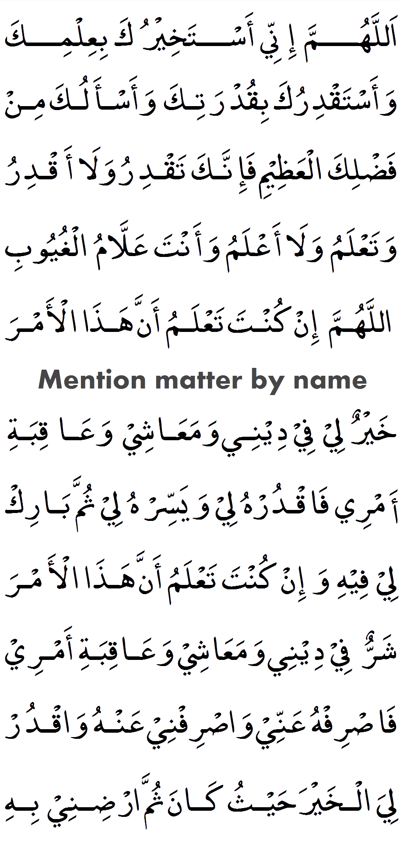
Allahumma innee astakheeruka bi ilmika wa-astaqdiruka biqudratika wa-as'aluka min fadhlika al-adheem. Fa innaka taqdiru walaa aqdiru. Wa ta'lamu walaa a'alamu wa anta allaamul ghuyoob. Allahumma in kunta ta'lamu anna haadhal-amr.
* Then the matter should be mentioned by name *
khayrun liy fiy deeniy wa-ma'aashiy wa-'aaqibat amriy, fa'qdruhliy wa-yassirh liy thumma baarik liy feehi. Wa in-kunta ta'lamu anna haadhal amr sharrun liy fiy deeniy wa-ma'aashiy wa-'aaqibat amriy. Fa asrifh annee wa-srif 'anhu. Wa aqdurh liyal khayr hayth kaana thumma a-rdhiniy bihee".

O Allah! Behold I ask You the good through Your Knowledge, and ability through Your Power, and beg (Your favour) out of Your infinite Bounty. For surely You have Power; I have none. You know all; I know not. You are the Great Knower of all things. O Allah! If in Your Knowledge this matter

* Then the matter should be mentioned by name *

be good for my faith (Deen), for my livelihood, and for the consequences of my affairs, then ordain it for me, and make it easy for me, and bless me therein. But if in Your Knowledge, this matter be bad for my faith (Deen), for my livelihood, and for the consequences of my affairs, then turn it away from me, and turn me away therefrom, and ordain for me the good wherever it be, and cause me to please with it.

16-4.When to pray:
‘Let him pray two rak’ahs of non-obligatory prayer.’ This is mentioned to make it clear that it does not mean fajr prayer, for example. Al-Nawawi said in al-Adhkaar: He can pray istikaarah after two rak’ahs of regular sunnah prayer done at zuhr for example, or after two rak’ahs of any naafil prayers whether they are regularly performed or not.

16-5.Wisdom:
The wisdom behind putting the salaat before the du’aa’ is that istikhaarah is intended to combine the goodness of this world with the goodness of the next. A person needs to knock at the door of the King (Allaah), and there is nothing more effective for this than prayer, because it contains glorification and praise of Allaah, and expresses one's need for Him at all times.

16-6.Answers:
The secret is that one’s heart should not be attached to the matter in question, because that will result in a person becoming restless. Being pleased with something means that one’s heart is content with the decree of Allah.
(At both instances where "haadhal amr" appears, mention affair here):

17.Prays(Du’a):
1-Upon Going to sleep.

Allah humma bis-mika aamu'tu wa aah'ya.
O Allah ,In Your Name, I die and I live.

2-Wake up from sleep.
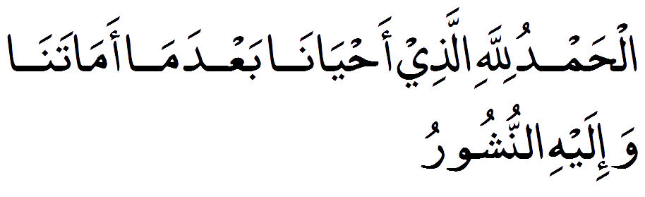
Alhamdu lillahil-lathee ahyana ba'da ma amatana wa-ilayhin-nushoor.
All praise be to Allah, who gave us life after killing us (sleep is a form of death) and to Him will we be raised and returned.
3-Entering the Toilet.
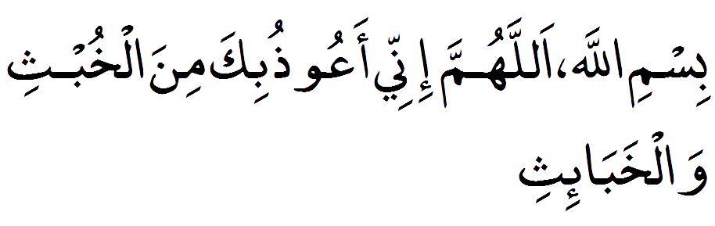
Bismil-lah – allahumma innee aa'oozuu bika minal-khubthi wal-khaba-ith.
In the name of Allah,O Allah. I seek refuge in You from the male female evil and Jinn's.

4-Leaving the Toilet.
Option 1

Option 2
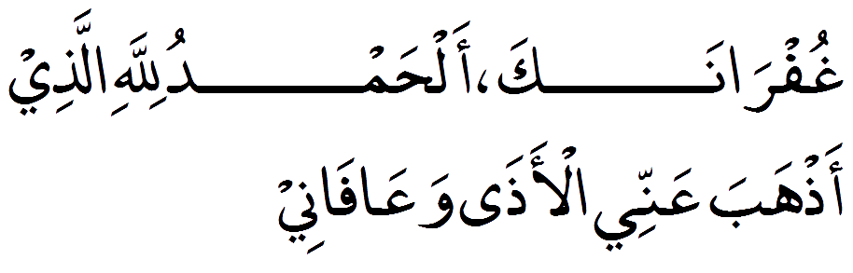
Ghufranak, alhamdu lillah-hil lazee-aaz haba annil-aaza wa'aafani.
O Allah, I seek forgiveness and pardon from You, All Praise be to Allah, who removed the difficulty from me and gave me ease (relief).

5.Before the Meals.

Bismil-lah
In the name of Allah
6.Forgetting to recite Bismillah.
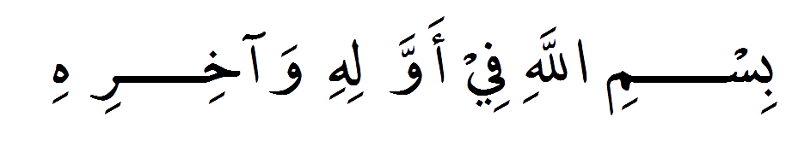
Bismil-lahi fee awwalihi wa-akhirih.
In the name of Allah in the beginning and end.

7.After meals.
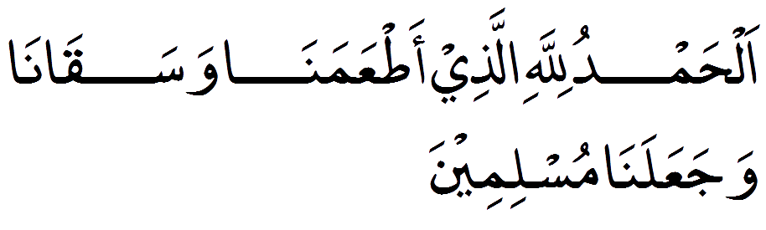
Alhamdu lillah hil lazi aat'aa mana wasakana wa-ja-aa lana Muslimin.
All praise belongs to Allah, who fed us and quenched our thirst and made us Muslims.

After meals (Second Option).

Allahumma barik lana feehi wa-aath-imna khayran minh.
O Allah, You grant us blessings in it and grant us better than it.

8.Leaving Home.
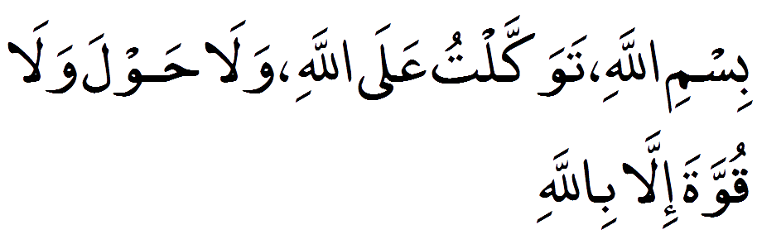
Bismil-lah, tawakkaltu alal-lah, wala hawla wala quwwata illa billah.
I depart with Allah's name, relying on Him. It is Allah who saves us from sins with His guidance (the ability to do so).

9.Entering Home.
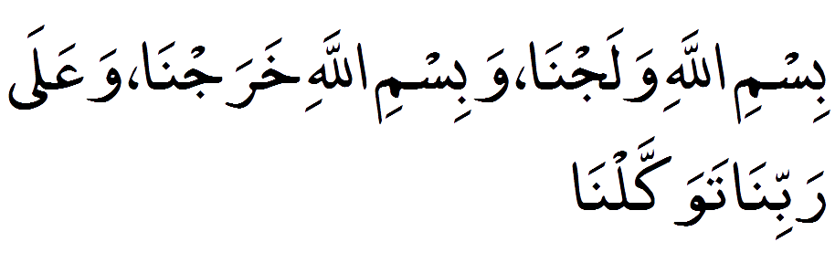
Bismil-lahi walajna, wabismil-lahi kharajna, wa'ala rabbina tawakkalna.
In the Name of Allah we enter , in the Name of Allah we leave , & upon our Lord we depend [then say As-Salaamu ‘Alaykum to those present].

10.On Journey.
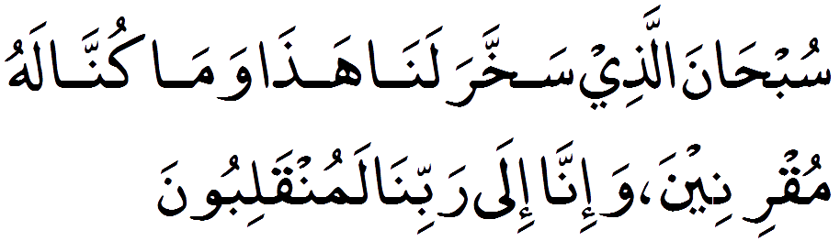
Subha-nal-lazi sakh-kha ralana haza wama kunna lahu mukhri-nee-na wa-inna ila rabbina lamun-qaliboon.
Allah is pure, He has given control and without His power we would not have any control Without doubt we are to return to him.

11.Return From Journey.
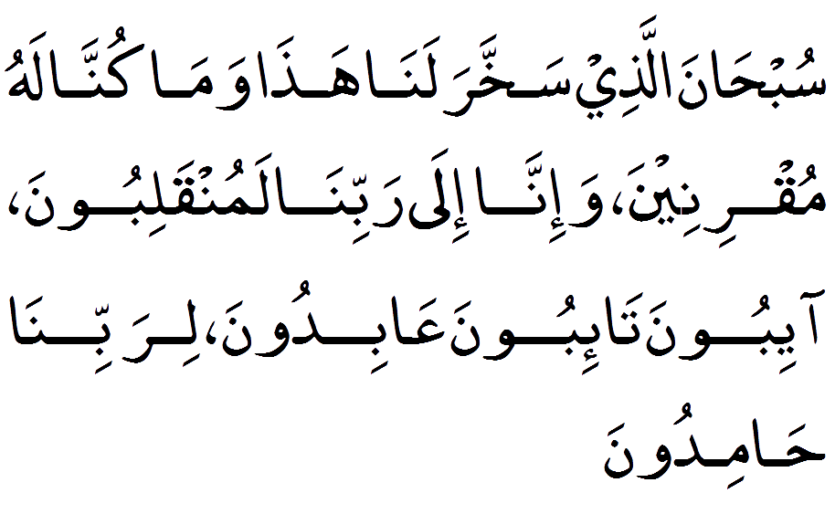
Subha-nal-lazi sakh-kha ralana haza wama kunna lahu mukhri-nee-n, wa-inna ila rabbina lamun-qaliboon, AAaiboona, ta-iboona, AAabidoona, lirabbina hamidoon.
Allah is pure, He has given control and without His power we would not have any control Without doubt we are to return to him, We return, repent, worship and praise our Lord.

12.Hearing someone sneeze.

Yaarha-muk-Allah.
May Allah have mercy on you.

13.Sneezers replies back.
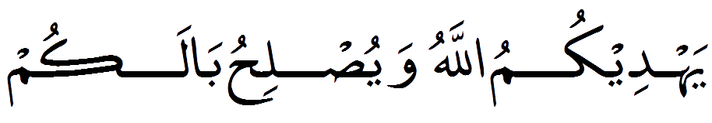
Yahdeekumul-lahu wayuslihu balakum.
May Allah guide you and rectify your condition.

14.Entering the Market .
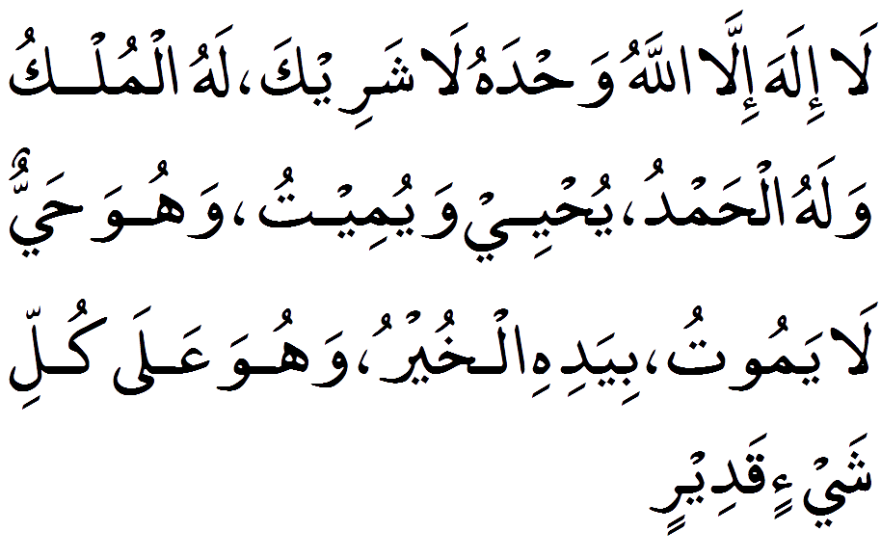
La ilaha illal-lah, wahdahu la shareeka lah, lahul-mulku walahul-hamd, yuhyee wa-yumeetu, wa'huwa hayyun la yamoot, biyadihil-khayru, wahuwa A'ala kulli shayin qadeer.

None has the right to be worshipped except Allaah, alone, without partner, to Him belongs all sovereignty and praise. He gives life and causes death, and He is living and does not die. In His hand is all good and He is over all things, omnipotent.

15.Having relation with wife.
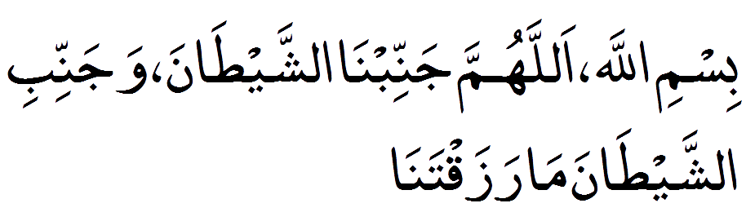
Bismillah, Allahumma Jannibna-sh-Shaitan, Wa Jannibi-sh-Shaitana ma Razaqtana.

I am having relations in the name of Allah. O Allah save us from Satan and keep him away from the children You grant us. The child that is born after the recitation of this dua will never be harmed by Satan.

16.One in Distress.
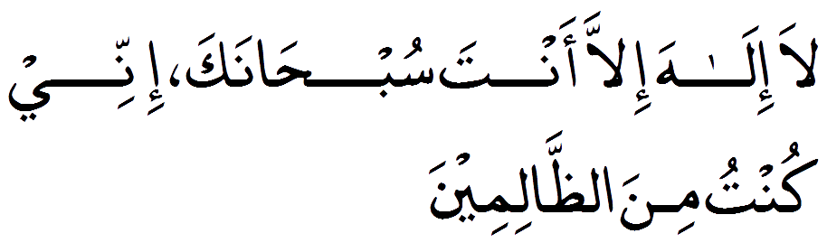
La Illaha Illa Anta Subhanaka Inni Kuntu Minz zalmin.
Non has the right to be worshipped except you. How perfect you are, verily I was among the wrong-doers.

17.Leaving all affair to Allah.

HasbunAllahu wa ni`mal wakil.
Allah is sufficient for us, and how fine a trustee (He is).

18.Protection from Hellfire.

Allah humma aa jirnee minan naar.
O Allah, save me from the fire.
19.Fear of shirk.
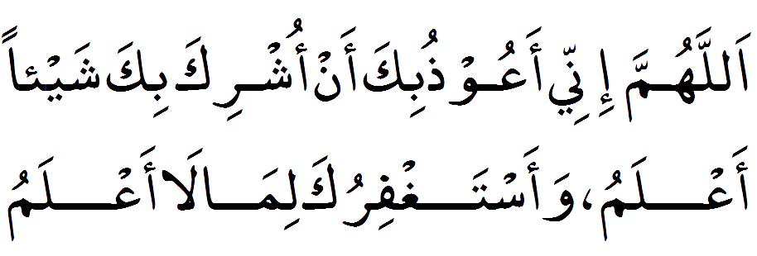
Allahumma innee a’oozu bika an ushrika bika shay-an a’alam, wa-astaghfiruka limaa laa a’alam.
O Allah we seek refuge in You from associating anything with You knowingly, and we seek Your forgiveness for what we do unknowingly.

20.Placing children's under Allah's protection.
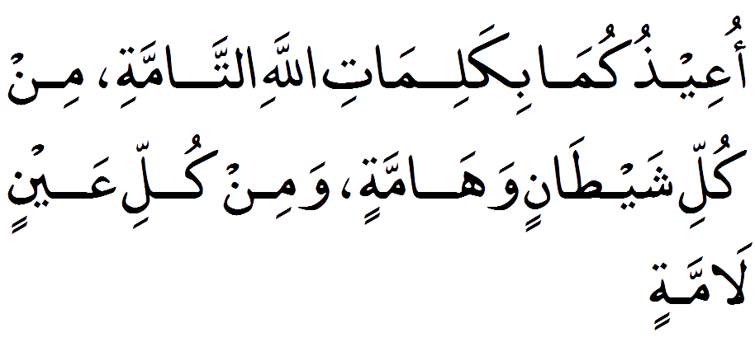
Oee-zukuma bikalimatil-lahit-tammah, min kulli shaytanin wahammah, wamin kulli aay-nin lammah.
I seek protection for you in the Perfect Words of Allah from every devil and every beast , and from every envious blameworthy eye.

21.Du'a for the Parents.
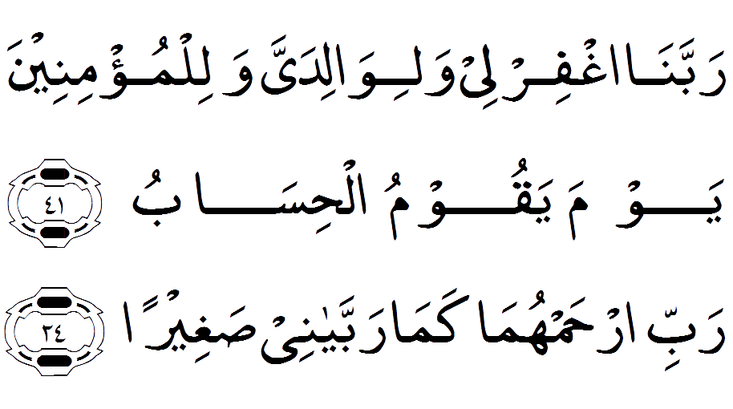
Rabbighfir lii wali-waalidayya walilmum-iniina yauma yaquumul hisaab (Also recite) Rabbirhamhumaa kamaa rabbayaani sag-hiiraa.
Our Lord! Forgive me and my parents, and (all) the believers on the Day when the reckoning will be established (Also recite) My Lord! Have mercy on them both as they did care for me when I was young.

22.Remembrance and glorification of Allah.
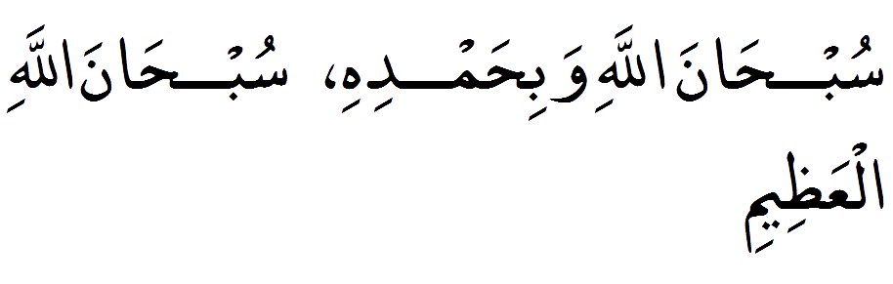
SubhanAllah wa Bihamdihi, SubhanAllah hil aahzim.
How perfect Allah is and I praise Him. How perfect Allah is, The Supreme.

23.Remembrance and glorification of Allah.

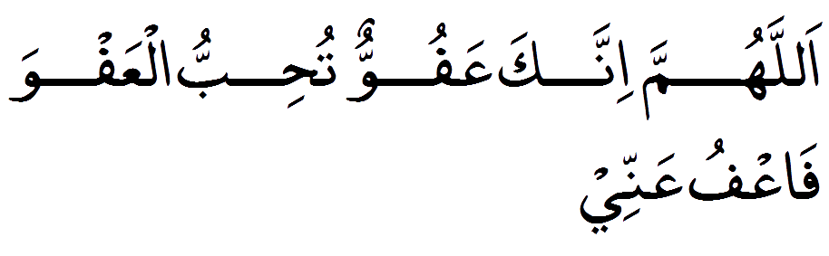
Allahumma innaka 'affuwwun tuhibbul 'afwa fa'fu anni.
O Allah You are The One Who pardons greatly, and loves to pardon, so pardon me.

24.Remembrance and glorification of Allah.

La hawla wa laqu-aata illah billah.
There is no might nor power except with Allah.

25.When visiting sick.

Laa ba'sa, tahoorun 'inshaa'Allaah.
Do not worry, it will be a purification (for you) Allah willing.

26.For good health [7 times].
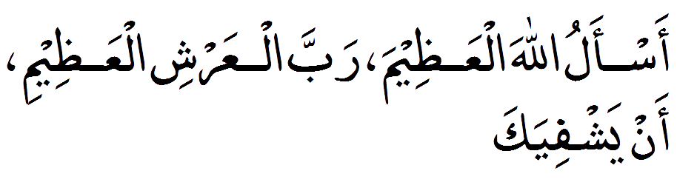
As'alullaahal'Adheema, Rabbal-'Arshil-'Adheemi. an yashfiyaka [Recite 7 times].
I ask Almighty Allah , Lord of the Magnificent Throne, to make you well. (Recite seven times in Arabic).
27.Cure of any illness.
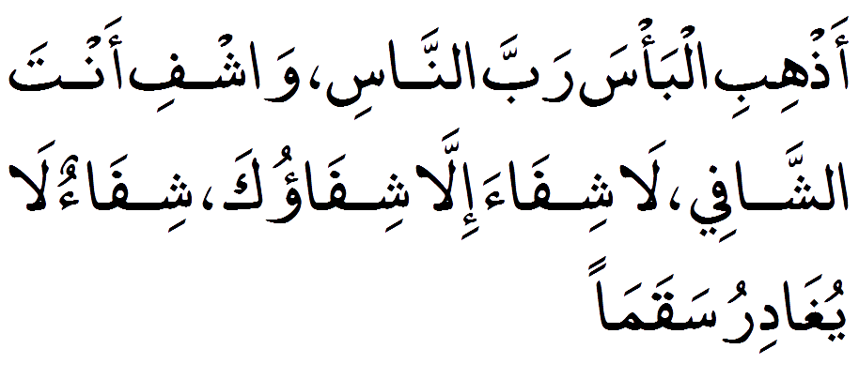
Azhibil-bah-saa rabban-naasi waasfi aan-tash-shafee la shifa-aah illah shifa-wooka shifa-woon laa you-gaa dee-ru sha-qaa-maa.
O Lord of the people, remove this pain and cure it, You are the one who cures and there is no one besides You who can cure, grant such a cure that no illness remains.

28.Visiting the graves.
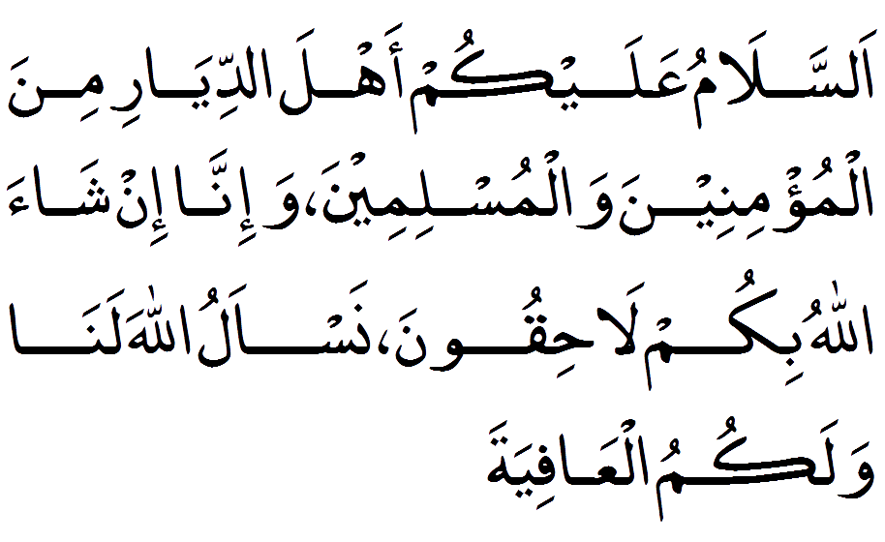
As-salaamu ‛alaykum ahl-ad-diyaari mi-nal-mu’mineena wal-muslimeena, wa in-naa in shaa’-allaahu la-laaḥiqoona, nas’al-ullaaha lanaa wa-lakumul-‛aafiyah.
Peace be upon you, people of this abode, from among the believers and those who are Muslims , and we , by the Will of Allah, shall be joining you. I ask Allah to grant us and you strength.

29.Difficult affairs [ie. Exams, Test].
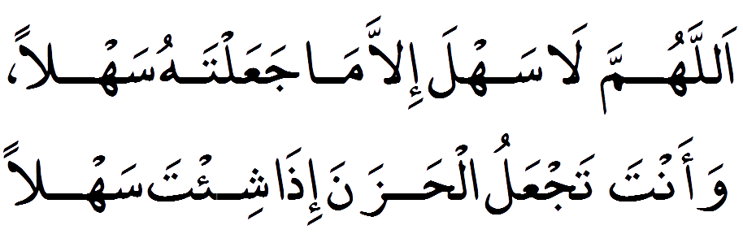
Allahumma la sahla illa ma ja’altahu sahla, wa ‘anta taj-alul hazna idha shi’ta sahla.
O Allah! There is nothing easy except what You make easy, and You make the difficult easy if it be Your Will.

30.When breaking fast.
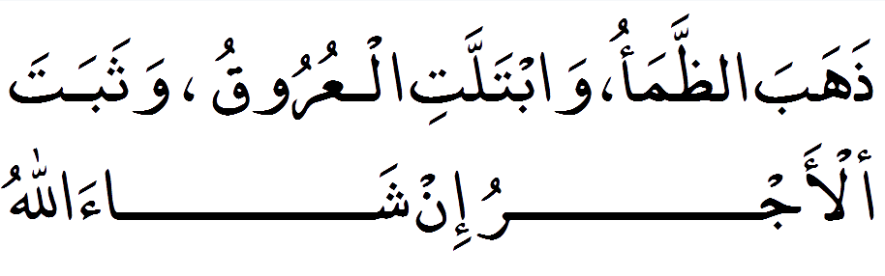
Zhahabadh-dhama'u, wabtallatil-'urooqu, wa thabatal-'ajru inshaa'Allaah.
The thirst has quenched and left wetness and with the will of Allah, reward is proven (certain).

